The Health Care Services (Provider Selection Regime) Regulations 2023
Competitive Process

INVITATION TO TENDER

for the provision of

Primary Medical Services (General Practice) under Alternative Provider Medical Services (APMS) Contract Arrangements
for
Lot 1: Burnley Practice
Lot 2: Canberra Old Oak Surgery
Lot 3: Mollison Way Surgery
Lot 4: Sudbury Surgery
for
NHS West & North London Integrated Care Board

Atamis Reference number: C444743

Document 2: Service Specification - Sudbury Surgery
Part 1 - General Service Delivery Requirements

The following words shall have those meanings as described below for the purposes of this Document 2 – Service Specification for Lot 4 Sudbury Surgery.

“Frontline Staff” means any staff or other persons engaged by the Contractor that have direct contact with patients.

“BNF” means British National Formulary.

Equity of Access

The Contractor shall:

not discriminate between Patients on the grounds of age, sex, sexuality, ethnicity, disability, or any other non-medical characteristics;

abide with the Equality Act 2010 and shall have due regard to the Public Sector Equality Duty when exercising public functions under this Contract;

implement and comply with the Accessible Information Standard (DAPB1605) ensuring that information and communication needs arising from disability, impairment or sensory loss are identified, recorded, flagged, shared (where appropriate) and met;

provide reasonable adjustments (including interpretation and translation) to enable equitable access to services which includes utilisation of available professional translation services;

as required for all non-English speaking Patients during all consultations.

to provide appropriate translations of materials describing procedures and clinical prognosis, where it is normal procedure to provide such materials in English, for the languages recommended by the Commissioner as being the most common languages spoken by Patients who are likely to use the Services; and

take reasonable steps to proactively deliver health promotion and disease prevention activities to all Patients underserved groups. The Contractor acknowledges that underserved groups shall include but not be limited to the following:

- those who do not understand written or spoken English;
- those who cannot hear or see, or have other disabilities;
- working single parents;
- asylum seekers or refugees;
- those who have no permanent address;
- gypsy travellers;
- black or minority ethnic communities;
- adolescents;
- carers, with particular emphasis on young carers;
- elderly and/or housebound people;
- those who have mental illnesses;
- those who misuse alcohol or illicit drugs;
- those who are unemployed; and
- those on probation in bail hostels and approved premises.

The Contractor acknowledges that to improve equity of access for ethnic minority communities, it is important to collect information on ethnicity and first language due to the need to take into account culture and language in providing appropriate care packages and the need to demonstrate non-discrimination and equality of access to service provision. The Contractor shall therefore be required to record the ethnic origin and first language of all Registered Patients. Patients must be informed that provision of ethnicity and language data is voluntary and collected for the purposes of improving equity of access and service quality.

Patient Dignity & Respect

The Contractor shall:

ensure that the provision of the Services and the Practice Premises protect and preserve Patient dignity, privacy and confidentiality;

allow Patients to have their personal clinical details discussed with them by a person of the same gender, where required by the Patient and if reasonably practicable;

provide a chaperone for intimate examinations if requested by the patient to preserve Patient dignity and respect cultural preferences; and

ensure that the Contractor Staff and anyone acting on behalf of the Contractor behaves professionally and with discretion towards all Patients and visitors at all times.

Informed Consent

The Contractor shall comply with NHS requirements in relation to obtaining informed consent from each Patient as notified to the Contractor by the Commissioner from time to time prior to commencing treatment including the following as amended from time to time:

Decision Making and Consent Guidance: GMC November 2020 and the DHSC Reference Guide to Consent for Examination or Treatment (2009), where still applicable as supplementary guidance;

Mental Capacity Act 2005 (MCA) and its Code of Practice including assessment of capacity, support to decide, best-interests decision making and appropriate documentation;

Applicable local consent policies.

Children and Young People

The Contractor shall:

provide services to children and young people in accordance with Working together to safeguard children (statutory guidance) and local multi-agency arrangements, ensuring timely assessment, information sharing and escalation where there are concerns about harm. Furthermore, ensure that the use of the Child Protection Safeguarding Information service is used within the service when a child is being registered within the systems;

ensure that the health and wellbeing of all children aged 16 and under that newly register with the practice is reviewed as part of a face to face consultation with the child within 30 days of registration with the practice;

ensure that the Contractor’s medical and Frontline Staff and anyone working on behalf of the Contractor are familiar with, and receive regular training in, local Child protection policies as directed by the Local Authority, the Local Children Safeguarding Board and the Commissioner and as amended from time to time;

participate in any supervision, work with, and accept relevant support from a registered Children’s nurse, Paediatricians, the Designated and Named Safeguarding Professionals within the local health care community;

ensure that any child record within the practice is linked to a parent on the system.

Prescribing

Without prejudice to Clause 19 of this Contract (which shall prevail in case of conflict or ambiguity with this paragraph 5), the Contractor shall:

prescribe the most clinically and cost effective medicines in accordance with national and local guidance from time to time including:

NICE guidance and Department of Health directives relating to prescribing;

Good Prescribing Practice as defined by BNF;

shared care protocols agreed between the Commissioner and other secondary care NHS Contractors; and

patient group directions, such as emergency contraception and antibiotics;

Meet all requirements of the prescribing or medicines management work plan agreed with the ICB. Engage in prescribing incentive scheme and meetings with medicine management link staff.

Clinical Safety & Medical Emergencies

The Contractor shall:

ensure that all Contractor Staff have and maintain basic life support certification with competence in defibrillation and ensure that all the Contractor Staff comply with the UK Resuscitation Council guidelines on basic life support and the use of automated external defibrillators;

ensure the availability of sufficient numbers of the Contractor Staff with appropriate skill, training and competency and who are able and available to recognise, diagnose, treat and manage Patients with urgent conditions at all times when the surgery is open;

possess the equipment and in-date emergency drugs including oxygen to treat life-threatening conditions such as anaphylaxis, meningococcal disease, suspected myocardial infarction, status asthmaticus and status epilepticus;

pass all life threatening conditions to the ambulance service as soon as practicable by dialling 999 and requesting the ambulance service or the dedicated telephone number for health care professionals (currently 020 3162 7525); and

adhere to any national or local guidelines relating to clinical safety and medical emergencies in primary care as amended from time to time.

Good Clinical Practice

Without prejudice to Clause 50 of this Contract, the Contractor shall perform the Services in accordance with the following requirements as amended from time to time:

Care Quality Commission Fundamental Standards (Health and Social Care Act 2008, Regulated Activities Regulations 2014), and alignment with the CQC Single Assessment Framework where applicable;

any relevant Medicines and Healthcare products Regulatory Agency (MHRA) guidance, technical standards, and alert notices;

the highest level of clinical standards that can be derived from the standards and regulations referred to in this paragraph 7.1 of Part 1 of Document 2; National Institute of Clinical and Care Excellence (NICE); and

the General Medical Council guidance on Good Medical Practice (2024).

The Contractor shall ensure that clinical meetings are convened for all clinicians working in the practice a minimum of once each calendar month.

Equipment

The Contractor shall provide all medical and surgical equipment, medical supplies including medicines, drugs, instruments, Appliances, and materials necessary for the delivery of services as per the definition in the APMS contract; which shall be adequate, functional, effective and calibrated.

The Contractor shall establish and maintain a planned maintenance programme for the equipment referred to in paragraph 8.1 above in line with the manufacturer’s guidance and make adequate contingency arrangements for emergency replacement or remedial maintenance.

Infection Prevention and Control

Without prejudice to clause 12 of this Contract, the Contractor shall have in place arrangements that meet the standards outlined in the NICE guidelines on infection control “Healthcare associated infections: prevention and control in primary and community care”, to maintain a safe, hygienic and pleasant environment at the Practice Premises, and NHS England publications including the “National Infection prevention and control manual for England”, and shall:

use only disposable medical devices where appropriate

make arrangements for the ordering, recording, handling, safe keeping, safe administration and disposal of medicines used in relation to the Services; and

make arrangements to minimise the risk of infection and toxic conditions and the spread of infection between Patients and staff (including any clinical practitioners which the Contractor has asked to carry out clinical activity).

ensure staff involved in the delivery of services complete Infection Prevention and Control (IPC) training and participate in the IPC self-assessment process using the MEG audit tool to ensure compliance with current regulatory standards and best practice.

Advice and Guidance and Referrals

The Contractor shall:

record all referrals in the patient record using the appropriate SNOMED CT;

Hospital Referrals

monitor and minimise inappropriate referrals and hospital admissions in line with the ICB annually agreed priorities and practice specific work plan;

provide complete and comprehensive information to support any referral made and comply with, where appropriate, any directions provided by the relevant ICB concerning the format or composition of referrals including, where relevant, instruction to direct referrals to a third party for clinic booking and/or clinical triage;

implement and operate the NHS e-Referral Service (e-Rs) (that was Choose and Book) at point of referral for services and provide a booking facility unless this is managed by a third party under contract with the ICB. (In accordance with the NHS Choice agenda). The Contractor shall take reasonable steps to ensure elective referrals are made electronically using the NHS e-Referral Service, unless the secondary provider has not made slots available on the system, there is a clinical need to refer to a provider who does not publish services on the system or patients have indicated their choice to be referred to a provider that does not publish services on the system;

Operate the Advice and Guidance platform (currently REGO) to seek specialty advice prior to making a referral.

Urgent Referrals

co-operate with and make effective use of:

111, including continuing to comply with the nationally mandated minimum number of 111 bookable appointments, currently set at one appointment per whole 3,000 registered patients and made available throughout the day. This requirement is subject to change under future national or local contractual amendments, and the Contractor will adjust the number, timing, and configuration of these slots in line with any updated NHS England or ICB specifications;

use the SDEC pathway in support of people with ambulatory urgent care needs;

implement and operate links with the Primary Care Enhanced Access Hub provided by the PCN to support effective urgent access for patients;

co-operate with service contractors carrying out Out of Hours Services to ensure safe and seamless care for Patients, including providing information on, as a minimum, a weekly basis and, where relevant, daily to such contractors carrying out Out of Hours Services on Patients that may require their services or who have special clinical requirements.

Integrated Neighbourhood team and Place based services

such as, the Care Connection team and the wider Integrated Neighbourhood Team;

commissioner - commissioned services provided outside acute hospitals, including health promotion services;

local authority services and employment advisers;

voluntary sector services; and

the Contractor shall become a member of the PCN that is aligned to its geography.

General use robust clinical pathways for referral, where these are agreed with other local healthcare Contractors and/or issued by the relevant ICB;

routinely collect and assess data about the appropriateness of the Contractor’s referrals, using audit and peer review to share learning;

implement national referral advice including Referral Guidelines for Suspected Cancer and NICE guidance;

ensure urgent suspected cancer referrals are sent electronically via NHS e-Referral Service and received by the relevant trust within twenty-four (24) hours and have a failsafe system in place for tracking these referrals;

review referrals practice every six (6) months as a minimum to ensure it is in line with latest guidance and protocols;

develop and implement policies in relation to nurse and nurse specialist referrals where nurses have an extended role in the treatment and investigation of Patients with specified diseases.

Co-operation with Other NHS Contractors, and Local Care Network

The Contractor shall have regard to all primary care commissioning policies (as updated from time to time at both local and national levels, and ensure that co-commissioning arrangements are implemented and amended from time to time (including arrangements for co-commissioning or joint commissioning with Integrated Care Boards).

The Contractor should actively participate in a Primary Care Network and be a core member practice.

The Contractor shall, together with the Commissioner:

establish good information flows to/from pathology and diagnostic Contractors and NHS and non-NHS Healthcare Professionals;

foster good working relationships and gain mutual understanding of systems, policies and procedures with key local stakeholders;

establish a directory of information regarding local resources and foster a good understanding of the local Patient care pathways to promote effective referrals; and

utilise specialist services (for example drug misuse, minor surgery, dermatology, NHS dentistry) from central primary care locations and other services at local locations to avoid duplication of services, promote economies of scale, and bring practices together to plan and implement common aims for the benefit of those practices and their patients.

The Contractor shall collaborate with the Commissioner in the following areas:

structures - to ensure that links are maintained with key individuals, departments, forums, groups and organisations within the Commissioner and local health and care economy, particularly with forums dealing with Patient and Public Involvement (an NHS defined term) which is an initiative to involve Patients and the public in the planning of services;

process – to ensure that similar policies and protocols are implemented by all Contractors and the Commissioner (e.g. clinical policies, workforce planning including training opportunities and structured secondment programmes subject to agreement by the Commissioner and Department of Health); and

outcomes – to ensure that key clinical indicators are in place to allow benchmarking with other equivalent services commissioned by the Commissioner and contribute towards the Commissioner’s own performance indicators;

For the purposes of this paragraph 11.4, the Contractor will, if requested by the Commissioner, nominate representatives for key planning forums such as the Local Care Network (currently the Place Based Partnership), the Commissioner’s Local Delivery Plans, Health Improvement Programmes, Strategic Service Development Delivery forums and nominate representatives for the Clinical Governance/Quality Committee and local Reforming Emergency Committees and ensure that service plans link with the plans of the Commissioner, the Local Place Based Partnership and local authorities.

The Contractor shall:

discuss and develop policies and procedures with local ICBs to ensure there is compatibility with local policies and procedures, including clinical and non-clinical issues;

sign up to multi-agency information sharing agreements as agreed with the Commissioner.

Clinical Governance & Quality Assurance

The Contractor shall:

show a commitment to achieve maximum points on the Quality and Outcomes Framework (QOF) and/or any future National Quality Framework;

show a commitment to achieve the highest banding across the range of indicators on the NHS England Assurance Framework and/or any future quality scorecard by preparing and implementing suitable action plans until the standard is achieved;

comply with any Quality Standards issued by the Department of Health and Social Care or its successor bodies for the London Region that may be introduced during the term of the contract, subject to the agreement of additional funding should it be reasonably required;

comply with Regulation 20 (Duty of Candour) of the Health and Social Care Act 2008 (Regulated Activities) Regulations 2014. Following any notifiable safety incident, the Contractor shall:

act in an open and transparent way;

notify the relevant person in person as soon as reasonably practicable, provide a truthful account, explain further enquiries, offer an apology and the record the discussion;

follow up in writing and provide ongoing support; records of notifications and correspondence shall be kept securely.

operate an effective, comprehensive, System of Clinical Governance with clear channels of accountability, supervision and reporting, and effective systems to reduce the risk of clinical system failure;

have medical leadership in place;

nominate a person who will have responsibility for ensuring the effective operation of the System of Clinical Governance and who is accountable for any activity carried out on a Patient;

be required to have regard to the Primary Care patient safety strategy (2024) and register with the national patient safety reporting system (LFPSE) Learning from patient safety events (unless their local risk management system is already connected to LFPSE);

respond to patient safety events using the Patient Safety Incident Response Framework (PSIRF) set out in the Patient safety strategy;

operate robust auditing of clinical care against clinical standards and in line with The Fundamental Standards (Regulated Activities Regulations 2014);

comply with the Commissioner’s governance requirements and inspections and make available, on reasonable notice to the Commissioner, any and all Contractor records (including permitting the Commissioner to take copies) relating to Contractor clinical governance to enable the Commissioner to audit and verify the clinical governance standards of the Contractor;

where appropriate, fully implement any recommendations following Commissioner guidance / advice as an outcome of patient safety and quality concerns;

provide the Commissioner with an annual report and service improvement plan on a template to be provided by the Commissioner;

Have an appraisal and training plan in place that supports all staff with continuing professional development and supervision;

participate in all quality and clinical governance initiatives agreed between the Commissioner and its other GP Practices;

proactively engage with acute provider partners to address patient safety concerns collaboratively, ensuring timely information sharing, joint learning, and coordinated actions to improve outcomes across the care pathway;

comply with all national and pan-London Safeguarding policies and procedures for Children and Adults, and have a Safeguarding Lead in place. Furthermore, the Contractor shall;

ensure they have their own Safeguarding policies covering Safeguarding children, Safeguarding adults and a process to manage allegations against a person in a Position of Trust;

include working in partnership with the Safeguarding Adult Board (SAB), its subgroups and contribute to its activities;

ensure staff receive supervision in relation to Safeguarding adults

ensure staff work with the Named GP, Designated GP or Professional as required

cooperate fully with NHS Trusts and Primary Care Networks to support statutory and operational requirements to learn from deaths and to report all deaths judged as likely to have been caused by problems in care in accordance with:

National Quality Board’s National Guidance on Learning from Deaths (2017);

Patient Safety Incident Response Framework (PSIRF), including the adapted model for primary care settings, as outlined in the NHS Primary Care Patient Safety Strategy (September 2024);

Learning from Lives and Deaths – People with a Learning Disability and Autistic People (LeDeR) programme);

Quality Account Regulations 2010 (as amended);

Relevant contractual obligations under the NHS Standard Contract and General Medical Services (GMS) Contract.

Practitioner Skill Mix/Continuity

The Contractor shall:

notify the Commissioner about any planned material changes to the skill mix of Clinical Staff at the GP Practice;

d

keep the Commissioner informed of any changes in the permanently employed GPs or nurse practitioners; and

take all reasonable steps to keep the use of locum GPs or nurses to a minimum.

Risk Management

The Contractor shall:

Operate mechanisms for assessing & managing clinical and general business risk including the maintenance of a suitable risk register that is reviewed, as a minimum by the business owners on a monthly basis;

prepare disaster recovery, contingency and business continuity plans that should be available for inspection by the Commissioner at any time, including the identification of a local “buddy practice” for business continuity purposes;

keep the Commissioner fully informed about any significant risks that have been identified that could impact on the performance of the contract;

notify the Commissioner of the person responsible for risk management within the contractor’s organisation;

Comply with the principles originally set out in the “Sign up to Safety” initiative (2014) and align with current national patient safety frameworks including the NHS Patient Safety Strategy (2019–2025) and the Patient Safety Incident Response Framework (PSIRF), as applicable.

Patient Records

The Contractor shall at its own cost retain and maintain all the clinical records using the ICB specified clinical system in accordance with:

Good Clinical Practice; and

this Part 1 of Document 2.

The Contractor shall take the necessary action to ensure legacy Lloyd George paper records are digitised in accordance with NHS England standards and uploaded to the National Document Repository (NDR), enabling secure, smartcard-accessible retrieval by authorised clinical staff.

If applicable, the Contractor shall at its own cost retain and maintain all the paper based clinical records in chronological order and in a form that is capable of audit.

The Contractor shall institute a programme of audit of individual clinicians’ electronic medical records on at least an annual basis for all clinicians engaged to work at the practice on the contractor’s behalf.

Contractor Records

The Contractor shall during the term of this Contract and for a period of six (6) years thereafter, maintain at its own cost such records relating to the provision of the Services, the calculation of the Charges and/or the performance by the Contractor of its obligations under this Contract as the Commissioner may reasonably require in any form (the “Records”), including information relating to:

contract management reporting;

national data set reporting. (This shall include full compliance by the Contractor with all of the requirements necessary for the operation of CQRS and GPES);

activity reporting, including:

monthly activity reporting to the Department of Health and Commissioner;

activity reporting in support of quarterly monitoring returns to the Department of Health (as agreed and advised by the Commissioner);

requisite data for payment purposes;

KPI measures (where not covered elsewhere); and

activity and outcomes data in support of service evaluation;

any management information relating to management information counts defined in the Technical Requirements for APMS Contract Changes as issued and updated from time to time.

The Contractor shall, subject always to the provisions of relevant legislation and Directions:

on request produce the Records for inspection by the Commissioner or, on receipt of reasonable notice, allow or procure for the Commissioner and/or its authorised representatives access to any premises where any Records are stored for the purposes of inspecting and/or taking copies of and extracts from Records free of charge and for the purposes of carrying out an audit of the Contractor’s compliance with this Contract, including all activities of the Contractor, the Charges and the performance, and the security and integrity of the Contractor in providing the Services under this Contract;

preserve the integrity of the Records in the possession or control of the Contractor and Contractor Staff and all data which is used in, or generated as a result of, providing the Services;

prevent any corruption or loss of the Records, including keeping a back-up copy;

provide any assistance reasonably requested by the Commissioner in order to interpret or understand any Records; and

take reasonable measures to ensure that the Records are updated using appropriate Read codes, using where applicable those Read codes required by the Commissioner and / or as required by the Technical Requirements for APMS Contract Changes.

The Contractor shall ensure that during any Records inspection the Commissioner and/or its authorised representatives receive all reasonable assistance and access to all relevant Contractor staff, premises, systems, data and other information and records relating to this Contract (whether manual or electronic).

Information Governance and Data Protection

The Contractor shall comply with UK GDPR and the Data Protection Act 2018, the Caldicott Principles and the NHS Records Management Code of Practice 2021.

The Contractor shall

ensure a lawful basis for processing, minimise data collected, maintain accuracy, protect confidentiality and security and respect data subject rights including timely responses to subject access requests;

complete and maintain DPIAs for high risk processing;

appoint/identify a Caldicott Guardian /SIRO function appropriate to the organisation’s size and risk profile;

manage record creation, retention, disposal and destruction inline with the Records Management code (including its retention schedule);

ensure that the NHS Data Security and Protection Toolkit (DSPT) is completed every year in line with the reporting requirements; and

ensure that the Electronic Patient Record (EPR) shares patients records in line with the NWL Data Sharing Agreements.

Part 2 - Services

Services To Be Provided By The Contractor

The contractor shall GP led primary medical care services as set out in this Document 2 Part 2 to patients residing in the Patient Registration Area and Outer Boundary Area, and / or patients registered with the practice as temporary patients.

Local Enhanced Services (LES) commissioned by the ICB may be available to the Contractor. Participation in any LES is optional and is not a requirement of this Contract. Where the Contractor elects to participate, such services will be commissioned and funded under separate arrangements as defined by the LES service specification.

Deliver the Services in accordance with the principles and requirements set out in the NHS England and Department of Health and Social Care’s Delivery Plan for Recovering Access to Primary Care (May 2023) , and any subsequent national policy, implementation guidance, and planning instructions issued during the term of the contract. This includes, but is not limited to, the Modern General Practice Access Model (2024), the NHS Mandate 2025, updated operational planning guidance, and any future national frameworks relating to access, digital transformation, workforce, and integrated neighbourhood care.

Access To Services

Opening hours

The Practice shall be open and Reception Services as defined below at paragraph 2.4, provided at all times during APMS Core Hours. APMS Core Hours are defined as:

DAY | Hours of Operation
Monday | 08:00 – 18:30
Tuesday | 08:00 – 18:30
Wednesday | 08:00 – 18:30
Thursday | 08:00 – 18:30
Friday | 08:00 – 18:30
Saturday | 09:00 – 13:00
Sunday | -

This is the minimum requirement and there is nothing in this Contract that prohibits the Contractor from opening and providing Reception Services outside of APMS Core Hours. For the avoidance of doubt, the Contractor will not be required to provide Out Of Hours (OOH) primary medical services under the Contract.

Provision of Reception Services

The Contractor must provide full reception services at the Practice Premises throughout the APMS Core Hours.

Reception services will include but not be limited to:

Answering the telephone which includes the bypass telephone provision by a practice staff member;

Free access to the premises without the need to be physically admitted;

Booking appointments and providing clarity on type of appointment (GP, nurse, pharmacist, etc);

Answering and co-ordinating Patient queries and requests including confirmation of “named GP”;

Signposting Patients to services;

Dealing with repeat prescription requests;

Registering new patients including providing guidance on online registration.

The Contractor shall ensure all reception staff receive training to enhance

the patient experience and mitigate the perception that reception reduces patient access and undermines trust. The training should promote a culture which demonstrates a courteous and supportive environment. Training must meet the national Care Navigation Training Standards (2024) and equip staff to direct patients to the most appropriate service at first contact.

The Contractor shall continually review patient satisfaction with Reception services to ensure expectations and standards are maintained especially in respect to professionalism, communication, confidentiality and complaint handling.

The Contractor shall continually review the waiting times associated with telephone lines to improve patient access. The Contractor must implement modern digital telephony with real‑time queue data, call‑back functionality and demand analytics in line with the Modern General Practice Access Model.

The Contractor shall ensure that the Reception layout and processes provides clear signage to assist with patient flow and protects privacy.

Registration Policy

The Contractor shall adhere to the GP registration principles outlined in the Primary Medical Services Policy and Guidance Manual (PGM), as amended or replaced from time to time.

The Contractor shall apply the Accessible Information Standard to registration ensuring communication needs are recorded / flagged and information is provided in accessible formats.

Registration practices shall reflect the Equality Act 2010 and PSED duties when delivering a public function with reasonable adjustments offered and no direct or indirect discrimination.

The Contractor shall ensure compliance with access rights for all individuals, including:

people without identification documents;

people experiencing homelessness;

people living in care homes, supported accommodation or other residential settings;

asylum seekers, refugees, and overseas visitors.

The Contractor shall maintain non-discriminatory registration practices in line with NHS policy, ensuring that patients are not refused registration on grounds of immigration status, housing situation, or inability to produce documentation. The Contractor must comply with NHS England’s Inclusive Registration Guidance (2024), ensuring zero‑tolerance for inappropriate registration refusal and supporting digital registration routes where available.

The Contractor shall submit and maintain registration processes and policies as required by the Integrated Care Board (ICB) or other relevant commissioning authority.

The Contractor shall ensure front-line staff are trained on registration principles and equipped to support vulnerable patient groups, including the use of access facilitators and care navigators where applicable.

Appointments, Bookings and Access

The Contractor shall ensure that all patients with recorded information or communication needs receive booking, notifications and consultations in formats and with support that meets their needs, in line with the Accessible Information Standard, Equality Act 2010 and the NHS Constitution.

The Contractor shall ensure that such needs are recorded, coded and prominently flagged within clinical and appointment systems, and that staff are trained to identify and act on them.

The Contractor shall maintain equitable non-digital access routes for patients who cannot or do not wish to use digital channels.

The Contractor shall offer a full range of consultation methods according to clinical need and patient preference including, but not limited to telephone, online and e-consultation, videoconferencing and face to face consultation at the GP Practice.

Digital and remote consultation options must comply with national standards for digital-first primary care, including use of approved online consultation tools, digital telephony and NHS App integration, and must be interoperable across neighbourhood teams. The balance of consultation modalities should be adjusted in line with clinical need, patient preference, safety and national guidance.

The Contractor shall undertake continuous assessment of its appointment system and access, monitoring demand and supply and taking action to address gaps in provision. Where necessary, the Contractor will make any necessary changes to facilitate access such as reviewing availability of pre-bookable appointments.

The Contractor shall use patient experience data (e.g. GP Patient Survey, Friends and Family Test, complaints) to inform continuous improvement of access and shall maintain a documented access improvement plan.

The Contractor must operate a same‑day assessment model for all clinically urgent needs, consistent with the Modern General Practice Access Model.

Booking an Appointment

Upon contacting the practice during APMS Core Hours by telephone, online request or in person, patients shall be require to make only a single contact to initiate care and shall not be asked to call back or re-submit a request.

All requests shall enter a same day assessment model consistent with the Modern General Practice Access framework including:

Care navigation by trained non-clinical staff;

Clinical triage where appropriate;

Clear response timeframes;

Same-day assessment for clinically urgent needs;

Timely response for routine needs in line with national access standards.

The Contractor shall ensure that:

Patients should be required to only make one contact in order to make an appointment and not be asked to call back;

Patients are able to book an appointment with an appropriate Health Care Professional within an appropriate timeframe based on clinical need, with same‑day assessment for urgent issues and timely access for routine care in line with national access standards;

Patients are able to book an appointment with the GP or other Health Care Professional of their choice. Access to a preferred clinician should be offered where clinically appropriate and operationally feasible, in line with continuity‑of‑care guidance;

Patients shall be able to book routine appointments in advance, normally up to four (4) weeks ahead, where clinically appropriate and subject to availability; and

If clinically urgent, a patient is able to book an urgent appointment on the same day.

Availability of Appointments

The Contractor shall participate actively in Integrated Neighbourhood Teams and neighbourhood‑level access arrangements, including extended access and shared clinics where agreed, ensuring interoperability of systems and appropriate data sharing in line with UK GDPR, the Data Protection Act 2018 and local shared care record arrangements.

The Contractor shall undertake continuous assessment of its appointment system and access, using demand and capacity data, patient experience feedback and equality impact assessments, and shall agree and implement improvement actions with the Commissioner where gaps are identified.

In order to ensure that demand for appointments is met, the Contractor shall provide as a minimum:

An average (mean) of 100 consultations with a GP or Nurse Practitioner (or other suitably qualified medical practitioner including ARRS roles) per 1000 Carr-Hill weighted registered patients per week during APMS Core Hours each contract year. This shall include providing a minimum of 72 consultations with a GP, Nurse Practitioner (or other suitably qualified medical practitioner including ARRS roles) per 1000 Carr-Hill weighted registered patients per week during APMS Core Hours for at least 46 weeks per contract year.

An average (mean) of 25 consultations with a Nurse or Healthcare Assistant (or other suitably qualified clinician with the express consent of the Commissioner) per 1000 Carr-Hill weighted registered patients per week during APMS Core Hours each contract year. This shall include providing a minimum of 25 consultations with a Nurse, Healthcare Assistant (or other suitably qualified clinician with the express consent of the Commissioner) per 1000 Carr-Hill weighted registered patients per week during APMS Core Hours for at least 46 weeks per contract year.

Ensure a duty doctor or Nurse Practitioner is available throughout APMS Core Hours to provide urgent consultations and house-calls.

For the purposes of measurement, the number of consultations counted referred to in this paragraphs 2.6.3 shall include face to face, telephone, video and e-consultations provided that full details of the consultation are recorded in the patients’ individual clinical records. The balance of consultation modalities should be adjusted in line with clinical need, patient preference, safety and national guidance.

For the purpose of calculating the measures in paragraphs 2.6.3, the Contractor will be required to calculate the number of consultations per 1000 Carr-Hill weighted patients each week of the contract year. The list size used for this purpose shall be the practice weighted registered list on the first day of each relevant quarter i.e. either 1st of April, July, October and January.

Length of Appointments

Appointment length shall be tailored to the clinical needs and complexity of the patient. Time allowed for booked face to face appointments shall be no less than:

Ten (10) minutes for a GP or Nurse Practitioner led appointment;

Fifteen (15) minutes for a Nurse or Healthcare Assistant led appointment except where the Nurse or Healthcare assistant is providing Phlebotomy services, influenza or other such immunisations under a vaccination programme;

Longer appointments should be available where clinically indicated to support access e.g. interpreter needed.

Punctuality of Appointments

Consultations shall commence within a reasonable timeframe of the scheduled appointment taking into account clinical priority and triage category.

Treatment for patients suffering from immediate and life threatening conditions (as determined by a clinically trained individual acting reasonably) must receive prompt assessment and treatment in line with national urgent and emergency care standard.

Home Visits

The Contractor shall conduct housebound patients’ home visits according to clinical need as determined by a GP acting in accordance with Good Practice:

The criteria for determining when home visits are necessary shall be consistently applied to patients and included within the practice leaflet and on any practice website;

Patients shall be seen as soon as practicable according to clinical need;

Patients shall be informed of the timescale in which they will be visited, and contacted if the agreed visit is expected to be delayed;

Home visits shall be appropriately indicated on the clinical system so that they can be audited and appropriately reported to the Commissioner;

Digital Primary Care Through Use of Technology

The Contractor shall implement the following Digital Primary Care schemes according to a timetable agreed with the Commissioner, taking into account those people who are users of assistive technology and ensuring compliance with national digital primary care standards and interoperability requirements.

Online Patient access to records

The Contractor shall take reasonable steps to ensure 90% of the patient population of the surgery have access to their online record, where it is appropriate for them to have access to;

Online booking and cancelling of appointments

The contractor shall take reasonable steps to allow patients to both book and cancel appointments via online routes;

Online ordering of repeat prescriptions;

The Contractor shall take reasonable steps to ensure that it transmits at least 90% of appropriate repeat prescriptions to the patients nominated pharmacy electronically using Electronic Prescription Services (EPS) Release 2 (or a later version of the software), unless the patient asks for a paper prescription or the necessary legislative or technical enablers are not in place. The Contractor must ensure EPS functionality is fully enabled and integrated with the NHS App and other approved digital channels.

Electronic and online consultations.

The Contractor must adhere to the contract in allowing patients to contact the practice during core hours via an online route for non-urgent appointment requests, medication queries and admin requests. Online consultation systems must meet NHS England’s standards for digital triage, accessibility, and safe clinical workflow integration.

Electronic receipt of Secondary Care Provider discharge summaries and subsequent post-event messages. The Contractor must ensure full interoperability with the NHS Federated Data Platform (FDP) and local shared care records where mandated nationally or by the ICB.

The Contractor shall proactively offer registered patients access to the services referred to in this section 2.10, providing clear information necessary to do so. The Contractor shall take reasonable steps to ensure that a level consistent with national digital uptake expectations, including promoting NHS App adoption as the primary access channel are using one or more of those online services described in this section 2.10.

The Contractor shall issue passwords and verify the identity of registered patients wishing to access the services in this section 2.10, as recommended by guidance from the Royal College of General Practitioners (RCGP). Identity verification should prioritise NHS Login as the default authentication method in line with national digital standards.

The Contractor shall ensure that its pages on its own website along with NHS Choices are updated regularly, and at all times provide complete and accurate information regarding the practice. The practice website must meet NHS England’s “Modern General Practice Access” website standards, including clear contact routes, digital access options, and accessibility compliance (WCAG 2.2 AA).

The Contractor shall proactively engage with patients to:

Promote and improve communication with patients on the benefits associated with primary care digital schemes;

Promote digital and online services (i.e. NHS APP) within the practice and on practice websites/social media pages.

Receive patient feedback on ease of use to mitigation patient frustration associated with reliability and limited functionality;

Feedback should be used to inform continuous improvement of digital services, including usability, accessibility, and integration with neighbourhood‑level digital pathways.

Patient Voice

The Contractor will work with different populations within their community and ensure that all patients achieve the best possible health outcomes, irrespective of ethnic differences. The Contractor should actively engage with their practice population to identify needs, provide culturally appropriate care and promote equitable access to health services.

Patient Participation Group (PPG)

The Contractor shall establish and actively support a Patient Participation Group (PPG), ensuring it remains representative of the practice population and inclusive of diverse patient voices. The PPG shall meet regularly at times determined by its members but as a minimum four (4) times per Contract Year, once in each three-month period. The Contractor shall also facilitate virtual engagement options to enable broader participation. The Contractor must ensure the PPG aligns with NHS England’s modern patient engagement expectations, including digital participation routes and targeted outreach to under‑represented groups. Areas for discussion shall be determined by the members and should include, but not be limited to:

Access, including opening hours, telephone access, availability of appointments digital access routes, support for the practice’s Modern General Practice Access Model implementation and contribute to the development and review of the Primary Care Network (PCN) access plan;

Clinical services;

Reception services;

Practice performance;

How patient feedback is being used to improve clinical standards and patient safety including learning from patient safety events in line with the Patient Safety Incident Response Framework (PSIRF);

How patient feedback is being used to improve patient experience;

Complaint handling and how complaints data informs continuous improvement and equity of access.

Patient Surveys

The Contractor shall be required to fully cooperate and assist the Commissioner in measuring patient satisfaction on an on-going basis. The method for measuring patient satisfaction will be determined by the Commissioner and may include touch screen, written surveys, interviews or other appropriate mechanisms. The methods may include, but not be limited to:

An annual locally administered survey of patients using a survey approved by the Commissioner;

The NHS GP Friends and Family Test;

The NHS England national annual GP Patient Survey;

The Contractor must also support digital feedback mechanisms, including NHS App feedback tools, and ensure accessibility for patients with communication or digital barriers.

The Contractor shall use patient surveys to help in the development of an annual patient experience improvement plan. The Contractor shall engage with the PPG to ensure there is transparency in terms of development and delivery

Practice Clinical Services

The Contractor shall:

Provide Essential Services and Additional Services to all Registered Patients, including patients registered as Temporary Residents.

Only be required to provide services during APMS Core Hours specified in this contract.

Provide Enhanced Services appropriate to the provision of care required by the health needs of the Contractor’s List of Registered Patients and directed by the Commissioner.

Participate in the Quality and Outcomes Framework (QOF) or any successor national quality framework introduced during the contract term.

Participate in the PCN DES, or any national iteration of the DES and contribute to neighbourhood‑level integrated care delivery as required by evolving NHS England policy.

Implement the Gold Standards Framework for patients requiring end of life care ensuring alignment with local palliative and end‑of‑life care pathways and digital shared care records.

Participate in and support Population Health Management, Health Promotion and Disease Prevention programmes including proactive identification of at‑risk cohorts using approved digital tools and contributing to neighbourhood‑level prevention initiatives.

Document any discussion around advanced care planning using the London Universal Care Plan.

Essential Services

The Contractor shall provide Essential Services at such times, within APMS Core Hours, as are appropriate to meet the reasonable needs of Registered Patients, including patients registered with the practice as Temporary Residents.

The Contractor shall have in place arrangements for Patients to access such services throughout the Opening Hours if clinically urgent and in accordance with relevant KPIs. This must include same‑day assessment pathways consistent with the Modern General Practice Access Model.

The Contractor shall provide:

Essential Services required for the management of Patients who are, or believe themselves to be:

ill with conditions from which recovery is generally expected;

terminally ill; or

suffering from a long-term condition.

Essential Services that are delivered in the manner determined by the GP Practice following discussion with the Registered Patient; and

Appropriate ongoing treatment and care to all Registered Patients taking account of their specific needs including:

advice in connection with the Registered Patient’s health, including relevant health promotion advice;

the referral of the Registered Patient for other services under the relevant Act; and

primary medical care services required in Opening Hours for the immediately necessary treatment of any person to whom the Contractor has been requested to provide treatment owing to an accident or emergency at any place in the Patient Registration Area.

For the purposes of the above section, “management” includes:

offering a consultation and, where appropriate, physical examination for the purpose of identifying the need, if any, for treatment or further investigation; and

making available such treatment or further investigation as is necessary and appropriate, including the referral of the Registered Patient for other services under the relevant Act and liaison with other Health Care Professionals involved in the Registered Patient’s treatment and care;

Implement and operate call and recall processes for reviews (annual or as appropriate), working with the wider integrated neighbourhood team to provide proactive care for people with long term conditions, complexity or frailty. Call/recall processes must align with national long‑term conditions frameworks and digital recall standards;

Outreach to the registered asylum seekers within the interim accommodation centres (hotels). Outreach must be delivered in partnership with local authority, voluntary sector and public health teams, ensuring culturally appropriate and trauma‑informed care.

Immediately Necessary Treatment

The Contractor shall provide primary medical care services required in Opening Hours for the immediately necessary treatment of any person falling within the following conditions described below who requests such treatment, for the period specified ensuring that such care is delivered safely, without discrimination, and in accordance with all applicable access and safeguarding requirements.

A person falls within this paragraph if they are a person:

whose application for inclusion in the Contractor’s list of Registered Patients has been refused and who is not registered with another contractor of Essential Services (or their equivalent) in the Practice Area;

whose application for acceptance as a Temporary Resident has been rejected;

who is present in the Practice Area for less than twenty-four (24) hours.

The period referred to in 6.1 above is:

in the case of 6.2.1 above, fourteen (14) days beginning with the date on which that person’s application was refused or until that person has been registered elsewhere for the provision of Essential Services (or their equivalent), whichever occurs first;

in the case of 6.2.2 above, fourteen (14) days beginning with the date on which that person’s application was rejected or until that person has been subsequently accepted elsewhere as a Temporary Resident, whichever occurs first; and

in the case of 6.2.3 above, twenty-four (24) hours or such shorter period as the person is present in the Practice Area.

For the avoidance of doubt, Essential Services provided by the contractor are deemed to include wound care and suture removal. The Contractor must ensure that immediately necessary treatment is recorded accurately and shared with relevant services where clinically appropriate, in line with information‑sharing standards and safeguarding duties.

Additional Services

The Contractor shall:

Provide Additional Services as defined in the relevant Directions for Alternative Provider Medical Services (APMS), and consistent with the definitions set out in the General Medical Services (GMS) Contract Regulations, as amended from time to time. This includes compliance with any updated national service specifications introduced during the contract term.

Provide Additional Services at such times, within APMS Core Hours, as are appropriate to meet the reasonable needs of Registered Patients.

Have in place arrangements for Patients to access such services throughout the Opening Hours if clinically urgent and in accordance with relevant KPIs. Urgent access must align with the Modern General Practice Access Model and local urgent care pathways.

Provide such facilities and equipment as are necessary to enable it properly to perform each Additional Service that it provides. Equipment must comply with current infection prevention and control standards and relevant national clinical guidance.

Provide the following additional services to Registered Patients:

Vaccinations and Immunisations;

Contraceptive Services;

Maternity Medical Services (excluding intra-partum care);

Child Health Surveillance Services;

Cervical Screening Services;

Minor surgery; and

Childhood Immunisations and pre-school boosters.

Additional Services must be delivered in accordance with the latest national service specifications and digital reporting requirements.

Vaccinations and Immunisations

The Contractor shall:

offer to provide to Registered Patients all clinically necessary vaccinations and immunisations including Childhood Vaccinations and Immunisations and influenza and pneumococcal vaccinations, in accordance with “Immunisation Against Infectious Disease 2005: "The Green Book" (as amended from time to time) and any subsequent national immunisation programme updates issued by UKHSA or NHS England;

provide appropriate information and advice to Registered Patients and, where appropriate, their Parents about such vaccinations and immunisations;

record in the Registered Patient’s record any refusal of the offer of all clinically necessary vaccinations and immunisations; and

Where the offer referred to above is accepted, the Contractor shall administer the vaccinations and immunisations, and include in the Patient’s record details of:

the Patient’s consent to the vaccination or immunisation or the name of the person who gave consent to the vaccination or immunisation and his relationship to the Patient;

the batch numbers, expiry date and title of the vaccine;

the date of administration;

in a case where two vaccines are administered in close succession, the route of administration and the injection site of each vaccine;

any contraindications to the vaccination or immunisation; and

any adverse reactions to the vaccination or immunisation.

All vaccination data must be submitted to national immunisation systems in accordance with digital reporting requirements.

The Contractor shall ensure that all staff involved in administering vaccines are trained in the recognition and initial treatment of anaphylaxis and any adverse reactions to the vaccination or immunisation. Training must be refreshed at intervals consistent with national immunisation training standards.

Contraceptive Services

The Contractor shall make available the following Contraceptive Services to all of its Registered Patients who request such services:

advice about the full range of contraceptive methods;

where appropriate, the medical examination of Registered Patients seeking such advice;

the treatment of Registered Patients for contraceptive purposes and the prescribing of contraceptive substances and appliances;

advice about emergency contraception and where appropriate, the supplying or prescribing of emergency hormonal contraception or, where the Contractor has a conscientious objection to emergency contraception, prompt referral to another Contractor of primary medical care services who does not have such conscientious objections. The Contractor must ensure same‑day access to emergency contraception in line with safeguarding and sexual health best practice;

the provision of advice and referral in cases of unplanned or unwanted pregnancy, including advice about the availability of free pregnancy testing in the Practice Area and, where appropriate, where the Contractor has a conscientious objection to the termination of pregnancy, prompt referral to another Contractor of primary medical care services who does not have such conscientious objections. Referrals must follow local pathways and ensure timely access to counselling and support services;

initial advice about sexual health promotion and sexually transmitted infections; and

the referral as necessary for specialist sexual health services, including tests for sexually transmitted infections. Referrals must align with local integrated sexual health service pathways and digital referral mechanisms;

In addition to the specific requirements of the GMS Contract Regulations, the Contractor shall co-operate with the Commissioner, Integrated Care Board (ICB), and/or relevant Local Authority to support and implement any reasonable initiatives aimed at reducing teenage conceptions, in line with local public health strategies and national guidance. This includes supporting targeted outreach and digital engagement initiatives for at‑risk groups.

Maternity Medical Services

The Contractor shall provide:

Registered patients with pre conception care;

Registered Patients who are pregnant, with all necessary Maternity Medical Services throughout the antenatal period in accordance with national maternity transformation guidance and local maternity system pathways;

Referrals to the Smoking Cessation Service for Registered Patients who are pregnant and who smoke;

Women who are Registered Patients and their babies with all necessary Maternity Medical Services throughout the postnatal period other than neonatal checks; and

All necessary Maternity Medical Services to Registered Patients if their pregnancy has terminated as a result of miscarriage or abortion or, where the Contractor has a conscientious objection to the termination of pregnancy, prompt referral to another Contractor of primary medical care services, who does not have such conscientious objections. Care must be trauma‑informed and aligned with local bereavement and early pregnancy loss pathways.

In this section:

“antenatal period” means the period from the start of the pregnancy to the onset of labour; and

“Maternity Medical Services” means in relation to women who are Registered Patients (other than babies), all primary care services relating to pregnancy, excluding intra partum care and in relation to babies, any primary care medical services necessary in their first fourteen (14) days of life; and

“postnatal period” means the period starting from the conclusion of delivery of the baby or the Registered Patient’s discharge from secondary care services, whichever is the later, and ending on the fourteenth (14) day after the birth.

Child Health Surveillance Services

The Contractor shall, in respect of any Child under the age of five (5) years for whom it has responsibility under this Contract:

provide the services described below, other than any examination so described which the Parent refuses to allow the Child to undergo, until the date upon which the Child attains the age of five (5) years; and

maintain such records as are specified below.

The services referred to above are:

Monitoring:

- by consideration of any information concerning the Child received by or on behalf of the Contractor;

- on any occasion when the Child is examined or observed by or on behalf of the Contractor;

- of the health, well-being and physical, mental and social development (“Development”) of the Child while under the age of five (5) years with a view to detecting any deviations from normal Development; and

- the breast feeding status of infants.

Examination of the Child at a frequency that has been agreed with the Commissioner in accordance with the nationally agreed evidence based programme set out in the fourth edition of “Health for all Children (David Hall and David Elliman Fourth Edition, Oxford University Press), as updated and maintained by the Royal College of Paediatrics and Child Health and other relevant national bodies. Examinations must be recorded in digital child health records where available.

Promotion of breast feeding in infants.

The records referred to above are an accurate record of:

- the Development of the Child while under the age of five (5) years, compiled as soon as is reasonably practicable following the first examination of that Child and, where appropriate, updated following each subsequent examination; and

- the responses (if any) to offers made to the Child’s Parent for the Child to undergo any examination referred to in section 7.5.

Bowel, Breast and Cervical Screening Services

The Contractor shall:

Supply any necessary information and advice to registered patients identified by the Commissioner as recommended nationally for screening tests in making an informed decision as to participation in the NHS Screening Programme’s (the “Programme”);

Perform cervical screening tests to registered patients who have agreed to participate in that Programme;

Registered patients to be informed of the results of the test;

Ensure that test results are followed up appropriately; and

Ensure the records referred are an accurate record of the carrying out of a cervical screening test, the result of the test and any clinical follow up requirements. Screening data must be submitted in accordance with national digital reporting requirements.

Minor Surgery Services

The Contractor shall make available to Registered Patients where appropriate:

Curettage and cautery and, in relation to warts, verrucae and other skin lesions, cryocautery; and

Management of minor injuries that do not require hospital assessment and care.

Ensure that its record of any treatment provided pursuant to paragraph 7.7.1 includes the consent of the Registered Patient to that treatment. Records must comply with national digital documentation standards.

Childhood Immunisations and Pre-School Booster Services

The Contractor shall:

Develop and maintain a register (Childhood Immunisation Scheme Register, which may comprise electronically tagged entries in a wider computer database) of all the Children for whom the Contractor has a contractual duty to provide childhood immunisation and pre-school booster services (who may already have been immunised, by the Contractor or otherwise, or to whom the Contractor has offered or needs to offer immunisations).

Undertake to offer the recommended immunisations to the Children on its Childhood Immunisation Scheme Register (with the aim of maximising uptake in the interests of Patients, both individually and collectively).

Undertake to record the information that it has in its Childhood Immunisation Scheme Register using any applicable national SNOMED CT codes in line with national requirements.

Develop a strategy for liaising with and informing parents or guardians of Children on its Childhood Immunisation Scheme Register about its immunisation programme with the aim of improving uptake.

Provide information on request to those parents or guardians about immunisation.

Aim to meet or exceed the average annual Cover Data achievement level of the London LAT or any updated national immunisation coverage targets.

Take all reasonable steps to ensure that the lifelong medical records held by a Child’s general practitioner are kept up-to-date with regard to the Child’s immunisation status, and in particular include:

any refusal of an offer of vaccination;

where an offer of vaccination was accepted;

details of the consent to the vaccination or immunisation (where a person has consented on a Child’s behalf, that person’s relationship to the Child must also be recorded);

the batch number, expiry date and title of the vaccine;

the date of administration of the vaccine;

where two vaccines are administered in close succession, the route of administration and any injection site of each vaccine;

any contraindications to the vaccination or immunisation; and

any adverse reactions to the vaccination or immunisation.

Ensure that any Health Care Professional who is involved in administering a vaccine has:

any necessary experience, skills and training with regard to the administration of the vaccine; and

training with regard to the recognition and initial treatment of anaphylaxis.

Ensure that:

all vaccines are stored in accordance with the manufacturer’s instructions; and

all refrigerators in which vaccines are stored have a maximum/minimum thermometer and that readings are taken from that thermometer on all working days. Cold chain breaches must be reported and managed in accordance with national guidance.

Provide the Commissioner with such information as it may reasonably request for the purposes of monitoring the Contractor’s performance of its obligations;

Have in place arrangements for an annual review of the service which shall include an:

audit of the rates of immunisation, which must also cover any changes to the rates of immunisation; and

analysis of the possible reasons for any changes to the rates of immunisation.

Improvement plans must be developed where uptake is below national thresholds.

Enhanced Services

The Contractor shall provide all clinically appropriate Enhanced Services subject to:

As directed by the Commissioner, to patients registered at the Practice Premises and shall enter into any other appropriate local contracts including any new or updated service specifications introduced by the ICB or NHS England during the contract term.

The Contractor should actively participate in a Primary Care Network DES and be a core member practice. Participation must include delivery of PCN service requirements, contribution to neighbourhood‑level planning, and compliance with any future national iterations of the DES.

Quality and Outcomes Framework (QOF)

With regard to the Quality and Outcomes Framework (QOF) as defined in the GMS Contract Regulations and/or any future National Quality Framework, the Contractor shall:

Participate in the QOF Scheme each year or any successor national quality framework introduced by NHS England;

Work towards gaining the maximum QOF points for each Contract Year securing the minimum standards set out in 12.1.1 of Part 1 of this Document 2;

Take all reasonable steps to minimise personalised care adjustments (PCAs) in line with national guidance and improve prevalence rates on practice registers;

Set standards over and above the QOF requirements to ensure Patients continually receive the highest standards of clinical care including proactive management of long‑term conditions and alignment with neighbourhood‑level quality improvement priorities.

Population Health Management Health Promotion and Disease Prevention

The Contractor shall:

Provide services focusing on health promotion and disease prevention and work with the Commissioner, ICBs, Local Authority, other local GP Practices and other health contractors on initiatives to promote health and prevent disease within the Commissioner’s area, participating in the priorities within the population health management programmes and undertaking population cohort stratification in support of those programmes using approved digital tools and data sources in line with national PHM guidance.

Ensure it has effective strategies for health promotion and disease prevention in place. These shall include but not be limited to:

smoking;

drug and alcohol use;

obesity;

lack of exercise;

dietary habits; and

sexual activity.

Strategies must reflect local Joint Strategic Needs Assessment (JSNA) priorities and ICB prevention frameworks.

Identify and proactively screen and manage Patients at risk of developing Long Term Conditions (see paragraph 10.10 below), cancers and sexually transmitted infections as well as those more likely to have unwanted pregnancies. Screening and case‑finding must align with national early diagnosis initiatives and local cancer alliance pathways.

Provide information about, and access to, self-management programmes for Registered Patients with long term conditions where appropriate.

Identify local care pathways for Registered Patients with Long Term Conditions to reduce inappropriate and unnecessary hospital admissions working with Integrated Neighbourhood Teams to deliver proactive, personalised care.

Provide information and advice to Registered Patients on self-monitoring for Long Term Conditions.

Participate in expert Registered Patient programmes.

Use digital, SNOMED‑compliant disease management templates that align with national long‑term condition frameworks; and

Implement appropriate DHSC, NICE, MHRA and any other relevant guidelines (as amended from time to time) that apply to the provision of primary medical care services for Registered Patients including updated NICE guidance on multi‑morbidity and personalised care.

For the purposes of this paragraph, “Long Term Conditions” shall be deemed to be those conditions that cannot, at present, be cured but which can be controlled by medication and other therapies.

The Contractor shall, at the minimum, be expected to achieve those standards in the key Public Health Targets including but not limited to:

flu vaccine uptake

pneumococcal vaccine uptake

shingles vaccine uptake

childhood vaccines uptake

cervical cytology screening

bowel screening

breast screening

diabetic retinopathy screening

abdominal aortic aneurism (AAA) screening

smoking cessation

obesity

alcohol consumption

Targets must reflect the latest national screening and immunisation standards and local ICB priorities.

For those standards in 10.11 that relate to cancer screening, the Contractor shall refer to the Transforming Cancer Services Team for London guidance document Good Practice Guide for Breast, Cervical and Bowel Cancer Screening in Primary Care, as updated from time to time and available via Transformation Partners in Health and Care. The Contractor must ensure alignment with local cancer alliance early diagnosis priorities.

Services Specific to Sudbury Surgery

The Contractor shall:

Liaise and work in partnership with other NHS healthcare contractors to review and reduce UTC and ED attendance using data‑driven approaches and contributing to neighbourhood urgent care pathways.

Regularly review referral activity to confirm that it is safe and clinically appropriate, and to work with system providers to address any areas of overperformance or underperformance.

Adopt a proactive approach to health promotion with registered patients. This may include outreach and promotional events (e.g. workshops) that will support preventative care. Outreach should prioritise underserved groups and align with local public health campaigns.

The Contractor must collaborate with the Primary Care Network (PCN) to ensure delivery of the PCN Network Contract DES. The PCN Network DES is made of the following components:

Access Hub DES (GP Extended Access): A Memorandum of Understanding (MOU) should be signed with the PCN or Federation to facilitate service delivery. Homes: The new provider will retain ongoing responsibility for their care homes currently aligned with the PCN.

Capacity and Access DES: The practice must continue working with the PCN to provide this service on an ongoing basis.

The Contractor must work with the PCN to agree on which PCN services should be delivered at scale under the Local Enhanced Services (LES) single offer, as well as those provided at practice level part of Brent local services.

Services Specific to Brent Local Place Partnership

The ICB will retain the right during the course of this contract to introduce further services specifications and KPIs to ensure equality of service provision to the patients registered with this practice compared to other GMS and PMS practices within the ICB area. The Contractor must comply with any such requirements and participate in local place‑based planning and performance improvement initiatives.

Part 3 – Staffing and Registration

Employment, Registration, Permits, and Vetting

The Contractor shall ensure that its recruitment, vetting, and employment practices enable compliance with the Care Quality Commission’s Fundamental Standards (Health and Social Care Act 2008, Regulated Activities Regulations 2014) and shall ensure alignment with the CQC Single Assessment Framework where relevant.

The Contractor shall comply with:

The relevant human resources provisions in the NHS Plan applicable to the Contractor and, where not directly applicable, the Contractor shall comply with the principles and spirit of the relevant human resources provisions in the NHS Plan;

The following policies and guidance as amended, updated or replaced from time to time:

NHS Employment Check Standards, March 2008 (revised September 2012 or from time to time thereafter) including any subsequent NHS England updates to identity, right to work, professional registration and safeguarding checks;

the Code of Practice for the International Recruitment of Healthcare Professionals (December 2004) (the “Code of Practice”) as updated by the Department of Health and Social Care (DHSC) and NHS England, including the current Ethical Recruitment List;

the Disclosure and Barring Service (DBS) Code of Practice for Registered Persons and other recipients of Disclosure Information published by the Home Office under the Police Act 1997 (revised April 2009) (“Code of Practice on Disclosure”);

the DHSC or NHS England guidance on the employment or engagement of bank staff, if any;

Any guidance and/or checks required under current national safeguarding legislation and policy including Disclosure and Barring Service (DBS) checks, DBS barred list checks and any other applicable safeguarding requirements;

Cabinet Office Statement entitled “Principles of Good Employment Practice (December 2010);”

The Cabinet Office Statement (as defined in Schedule 1); and

all relevant employment legislation and codes of practice applicable in the UK including updated NHS England workforce, equality, and inclusion standards.

The Contractor shall ensure that all Contractor Staff:

Have all necessary permits and/or entitlements to work in England in relation to the provision of the Services including compliance with NHS England’s Right to Work verification standards;

Are able to communicate in English at a level appropriate to their role so that they are able to communicate effectively with Patients and other persons in relation to the Services, including (where relevant) IELTS/PLAB tests as detailed in the Code of Practice for NHS Employers as amended from time to time in relation to the international recruitment of Health Care Professionals. Communication standards must align with the Health and Care Professions Council (HCPC) and Nursing and Midwifery Council (NMC) English language requirements where applicable;

Are registered with all appropriate regulatory bodies including without limitation the following:

for medical Contractor Staff, the GMC;

for nursing Contractor Staff, the Nursing and Midwifery Council; and

for Contractor Staff who are other Health Care Professionals (including Allied Health Professionals and Health Care Scientists (where appropriate)), the Health and Care Professions Council (HCPC).

The Contractor shall ensure that:

Medical Contractor Staff performing specialist procedures, are suitably qualified, competent and experienced and are registered in the GMC Specialist Register in respect of the specialty in which they perform specialist procedures;

GPs are:

registered with the GMC; and

hold appropriate certificates confirming their eligibility to work in general practice including compliance with the Medical Performers List (MPL) requirements;

Nursing Contractor Staff are registered on the Nursing and Midwifery and NMC Register and, if they are to prescribe drugs and/or medicine, that the corresponding entry in the register indicates they hold a prescribing qualification;

Eligible staff performing Cervical screening are registered, have completed the appropriate sample taker training and have the appropriate PIN to be able to carry out the screening in the designated area / locality and maintain competency in line with national cervical screening training standards; and

Appropriate arrangements are in place for re-registering and monitoring subsequent re-registration for Health Care Professionals as appropriate including annual appraisal, revalidation, and mandatory training compliance.

Workforce Strategy

The Contractor shall ensure that:

its staffing arrangements (as may be amended or updated from time to time by prior written agreement between the parties) are sufficient to mobilise and manage the provision of the Services during any change period and throughout the term of this Contract taking into account estimated growth and Patient numbers (where appropriate); and

there are, at all times, sufficient numbers of Contractor Staff engaged in the provision of the Services with the requisite level of skill and experience to cover Contractor Staff absences (for example, holidays and sickness) and to cope with planned or unplanned increases in workload. Workforce planning must align with Integrated Neighbourhood Team workforce models and NHS England workforce standards.

Subject to the Contractor’s obligations to comply with Clause 67 of this Contract, the Contractor shall (and shall procure that any of its sub- Contractors shall), allow the Commissioner full access, on an open book basis, to any information or data in respect of all employees or other persons employed or engaged in the provision of the Services, or in relation to any recruitment or any other matter concerning this Contract, which the Commissioner considers relevant. Workforce data must be accurate, complete, and submitted in accordance with national reporting requirements.

The Contractor shall:

implement workforce management information systems which are capable of delivering any internal and external monitoring and workforce reporting requirements and of monitoring compliance with the Working Time Regulations and NHS England workforce assurance standards;

provide timely and accurate workforce reports including, if required, input into the annual NHS workforce census and the NHS vacancy surveys; and

if requested by the Commissioner, use its best endeavours to procure that Contractor Staff participate in the annual NHS staff survey and act on survey findings to improve staff wellbeing and retention.

The Contractor shall have an operational management organisation structure chart which demonstrates the key operational management roles and responsibilities, reporting relationships and accountabilities. The Contractor shall inform the Commissioner within five (5) working days if they make any material changes to this chart.

The Contractor shall have a designated role responsible for Staff management, leadership and practice management, known as “the Practice Manager”. The Practice Manager must have appropriate training and experience in primary care operational leadership.

The Contractor shall adopt recruitment and retention strategies that will reduce the reliance on locum / temporary staffing arrangements and promote continuity of care for patients. This will include initiatives to support staff at work including wellbeing initiatives, supervision, and career development pathways.

Contractor Staff Recruitment

The Contractor shall ensure that:

any recruitment agency partners used for recruitment or engagement in the UK are compliant with NHS Employers Code of Practice for NHS Employers as amended from time to time;

in employing or otherwise engaging Clinical Staff it complies with the agreed person specifications as minimum requirements in terms of qualifications, knowledge, skills and experience;

all Clinical Staff are covered by appropriate indemnity insurance;

interviews of Clinical Staff take place with a suitably qualified interview panel, that proper references are sought and that professional qualifications are verified; and

its recruitment policy, strategies and supporting processes must promote equal opportunity and anti-discriminatory practice to enable them to attract and retain a high quality, competent workforce in adequate numbers, for the duration of the Contract. Recruitment processes must align with NHS England equality, diversity and inclusion (EDI) standards.

Appointment of Contractor Staff

The Contractor shall:

comply with the rules and requirements regarding employment checks as set out in the NHS Employment Check Standards, March 2008 (as amended in September 2012 and as may be further amended from time to time) including updated NHS England identity, right‑to‑work, professional registration, and safeguarding check requirements;

comply with the Cabinet Office Statement entitled “Principles of Good Employment Practice (December 2010);”

ensure that all Contractor Staff receive Training, supervision, necessary induction and are competent and fit for purpose to ensure the proper performance of the Services in accordance with this Contract and any NHS Requirements of which the Contractor is notified from time to time. Training must include mandatory safeguarding, infection prevention and control, equality and diversity, and information governance modules;

ensure that it will not use any individual for the performance of the Services in respect of whom an Healthcare Professional Alert Notice has been issued;

ensure that it is (and at all times during the term of this Contract shall be) a Registered Person within the meaning of the Police Act 1997 and the Police Act 1997 (Criminal Records)(Registrations) Regulations 2006 and an Umbrella Organisation within the meaning of the Code of Practice on Disclosure (for the purposes of applications made in relation to any sub-contractors of the Contractor) and that it complies at all times with the provisions of the Rehabilitation of Offenders Act 1974, the Police Act 1997, the Police Act 1997 (Criminal Records)(Registrations) Regulations 2006 and the Code of Practice on Disclosure as amended from time to time;

ensure that it shall not (and shall procure that its sub-Contractors shall not) employ or engage any person in relation to the Services unless the highest form of available Disclosure is obtained by the Contractor as follows:

if such person would be employed or engaged in an ERC Position or CRC Position, unless and until such person provides the Contractor with Enhanced Disclosure and the relevant Standard Disclosure as appropriate; and

unless and until such person to whom paragraph 4.1(f)(i) would not apply provides the Contractor with Standard Disclosure and, for the avoidance of doubt, if it is not possible to obtain Enhanced Disclosure from the Disclosure and Barring Service (DBS) (formerly the Criminal Records Bureau) in respect of such person, unless and until such person provides the Contractor with a copy of the information supplied by the relevant Data Controller in response to a subject access request by such person in respect of Personal Data held on the Police National Computer in relation to that person. DBS checks must be renewed or updated in accordance with NHS England safeguarding workforce standards;

ensure that it shall not (and shall procure that its sub-contractors shall not) employ or engage any Overseas Person in relation to the Services unless and until the Contractor and/or any sub-contractor of the Contractor and/or the Overseas Person (as the case may be in each relevant country) provide(s) Overseas Disclosure in respect of:

each country outside the United Kingdom of which the Overseas Person is a citizen;

each country outside the United Kingdom of which the Overseas Person holds a relevant professional qualification; and

each country outside the United Kingdom of which the Overseas Person has worked;

save in circumstances in which it is not possible for the Contractor and/or any sub- contractor of the Contractor and/or the Overseas Person using best endeavours to obtain Overseas Disclosure in or in relation to a particular country. Overseas recruitment must comply with the DHSC Ethical Recruitment List and NHS England international recruitment guidance. For the avoidance of doubt, Overseas Persons shall also be subject to the DBS provisions set out in paragraph 4.1(f) and the Contractor shall obtain, or procure the obtaining of by any sub- Contractor of the Contractor /or the Overseas Person, as appropriate, (in respect of any country where Overseas Disclosure is available) the highest form of available Overseas Disclosure. In circumstances in which it is not possible in respect of an Overseas Person for the Contractor and/or any sub-contractor of the Contractor and/or the Overseas Person using best endeavours to obtain Overseas Disclosure in relation to a particular overseas country, the Contractor shall (and shall procure that any sub- contractor of the Contractor shall) not employ or engage any such person in relation to the Services by the Contractor or any sub- Contractor of the Contractor, without the Commissioner’s prior written consent;

procure that no person (which shall for the purposes of this paragraph include any Overseas Person) who discloses any Convictions, or in respect of whom any other matter is revealed following Disclosure or Overseas Disclosure, in either case, of which the Contractor is aware or ought to be aware, is employed or engaged in the provision of the Services or any activity related to or connected with the provision of the Services by the Contractor or any sub- Contractor of the Contractor, without the Commissioner’s prior written consent. Risk assessments must be completed for any positive disclosure in line with NHS safeguarding policy; and

ensure that the Commissioner is kept informed at all times of any person employed or engaged by the Contractor or any of its sub-contractors in relation to the Services who, subsequent to his/her commencement of such employment or engagement, receives a Conviction of which the Contractor or any sub- contractor of the Contractor becomes aware or whose previous Convictions become known to the Contractor or any sub-contractor of the Contractor:

The Contractor shall implement an appropriate competency assessment process that includes competency assessment tools, to assess the practical competency of all Clinical Staff on recruitment. The Commissioner reserves the right to introduce specific appropriate competency assessment tools at any time during this Contract and require the Contractor to include them in its recruitment and induction process. Competency assessments must be documented and retained in staff files.

The Contractor must implement a comprehensive induction programme and shall ensure that every member of Contractor Staff is trained and assessed as competent during induction to:

administer basic life support; and

use automated external defibrillators.

Induction must also include safeguarding, infection control, information governance, and incident reporting training.

The Contractor shall have in place contingency arrangements to ensure adequate, available cover in the case of any:

planned or unplanned increases in workload;

Contractor Staff absences; and

medical emergencies.

Contingency plans must align with business continuity and emergency preparedness requirements.

The Contractor shall make available to all Contractor Staff as soon as reasonably practicable, a staff handbook that will include details of its:

employment terms and conditions;

HR policies; and

performance management policy.

The handbook must be reviewed annually and updated to reflect changes in legislation and NHS workforce policy.

The Contractor shall manage the Contractor Staff based on principles of equal opportunity, anti-discriminatory practice, equity and fairness, communication and involvement and confidentiality. Workforce policies must align with NHS England Equality, Diversity and Inclusion (EDI) standards.

The Contractor shall have a comprehensive health and safety policy that complies and discharges their duties with the Health and Safety at Work Act 1974 and Management of Health and Safety at Work Regulations (1999). The Contractor shall ensure that the health and safety policy includes:

The written statement (as required by section 2(3) of the Health and Safety at Work Act 1974 and the Management of Health and Safety at Work Regulations 1999, if applicable) (or EU member state equivalent) of the organisation;

The name and status of the person responsible for the implementation of the organisation’s health and safety policy;

A description of how the Contractor will manage its obligations in respect of health and safety at work; and

A description of how health and safety responsibilities are allocated within the organisation.

The policy must be reviewed annually and after any significant incident or organisational change.

Terms and Conditions and Employee Relations

The Contractor shall:

ensure that all monies, salary, benefits, tax and national insurance contributions due to be paid to any Contractor Staff or the Inland Revenue, relating to the provision of Services by the Contractor, shall be paid up in full by the Contractor and the Contractor shall fully indemnify the Commissioner in respect of any losses incurred by the Commissioner as a result of the Contractor 's breach of this paragraph 5.1(a); and

Ensure that its human resources and workforce policies and procedures do not conflict with the aims and objectives of the HR strategy elements in the NHS Plan, adhere to best employment practice and principles contained in the NHS People Plan, “Agenda for Change” and “Pay Modernisation” initiatives.

Workforce policies must also align with the NHS People Promise, NHS England Equality, Diversity and Inclusion (EDI) standards, and current national workforce wellbeing requirements.

Staff Performance Management

The Contractor shall:

Put in place a performance management policy and suitable arrangements for handling concerns about the conduct and performance of all Contractor Staff including compliance with NHS England’s “Maintaining High Professional Standards” where applicable;

Comply with the requirements of the regulatory bodies for revalidation and re-registration;

Put in place processes to ensure robust clinical governance and perform appropriate clinical audits for the continuing professional development of Contractor Staff needs following regular appraisals of Contractor Staff. Clinical governance processes must align with the Patient Safety Incident Response Framework (PSIRF); and

Ensure that Contractor Staff are aware of the needs of those working in a health service environment, observe the highest standards of hygiene, customer care, courtesy and consideration, and keep confidential all confidential information and information relating to any Patient. Confidentiality requirements must comply with the UK GDPR, Data Protection Act 2018, and NHS information governance standards.

The Commissioner shall have the right to order the removal from the performance of the Services, or prohibit from further involvement in the provision of the Services any person employed or engaged by (or acting on behalf of) the Contractor whose presence and/or involvement, (in the opinion of the Commissioner) is likely to have a material adverse effect on the performance of the Services or is otherwise undesirable. The decision of the Commissioner in this regard shall be final and conclusive, and the Contractor shall immediately comply with such instruction. Any such instruction shall not give rise to any liability whatsoever on the part of the Commissioner to the Contractor or any other party and shall not affect in any way the obligations of the Contractor to carry out the Services to the Specifications. Where any such person is removed, the Contractor shall, as soon as it is reasonably practicable thereafter, supply a replacement where, as agreed between the parties, this is required to ensure the proper performance of the Services and/or to ensure that the Contractor complies with its obligations to carry out the Services to the Specifications. The Contractor must ensure that any concerns leading to removal are managed in accordance with fair employment practices and safeguarding requirements.

The Contractor shall ensure that appropriate arrangements are in place for the supervision of all Clinical Staff. For GPs, this will include the conduct of peer reviews of each other’s performance once a month, to assess their own work and discuss clinical outcomes and specific cases of clinical importance for the team. The Contractor shall ensure that this process is conducted in line with good audit practice. Supervision arrangements must align with national clinical supervision standards and be documented.

Contractor Staff Training and Development

The Contractor shall:

Ensure that all Contractor Staff involved in treating Patients are appropriately trained and competent to carry out the roles required of them for the duration of this Contract;

Facilitate and provide access to the training and continuing professional development of Contractor Staff and ensure that all Contractor Staff receive such training, supervision and induction as is necessary to ensure the proper performance of the Services in accordance with this Contract;

Develop and implement a training plan for all Contractor Staff to ensure the safe and correct operation of all systems and equipment and adherence to processes and procedures in order to meet mandatory/statutory training requirements. Mandatory training must include safeguarding, infection control, information governance, fire safety, equality and diversity, and basic life support;

The training plan should promote a culture which demonstrates a caring, empathetic, courteous and supportive environment;

Implement a continuing professional development (CPD) plan, which must align with NHS England workforce development frameworks, for all Contractor Staff which will:

promote a patient-centred approach, including the dignity of the Patient, carers and relatives;

ensure that all Clinical Staff involved in treating patients are appropriately skilled, trained and competent to carry out the roles required of them for the duration of the Contract;

ensure the safe, correct and up to date operation of all systems, processes, procedures and equipment;

respond to individual training needs arising from Contractor Staff performance appraisal and clinical supervision;

respond to the individual professional development needs of Contractor Staff;

support workforce strategies;

comply with the provisions of Standards of Better Health and equal opportunities and anti-discriminatory employment legislation;

meet the requirements of professional bodies for re-registration and revalidation; and

ensure that clinical supervision for GPs includes the conduct of peer reviews of performance no less than once every month to discuss the work of the GP, clinical outcomes and specific cases of clinical importance to the team.

Consequences of Termination

The Contractor shall:

For a reasonable period both before and after the termination of this Contract, fully co-operate with the Commissioner and any successor providing services similar to the Services (or any part of them) in order to achieve a smooth transfer of the delivery of such services and to avoid any inconvenience or any risk to the health and safety of Patients and/or of employees of the Commissioner and/or members of the public, including continuing to provide the Services (which shall be paid for by the Commissioner in accordance with this Contract) until otherwise directed by the Commissioner; and

Fully co-operate with the Commissioner in the event that the Commissioner conducts a competition prior to the Expiry Date with a view to entering into a contract for the provision of services (which may or may not be the same as, or similar to, the Services or any of them) following the expiry of this Contract, including providing any information which the Commissioner may reasonably require to conduct the competition (such as information relating to the terms and conditions of employment or engagement of Contractor Staff and numbers and job descriptions of Contractor Staff involved), although the Contractor shall not be required to provide information which is commercially sensitive (i.e. information which would, if disclosed to a competitor of the Contractor, give that competitor a competitive advantage over the Contractor and thereby prejudice the business of the Contractor). All information sharing must comply with UK GDPR and the Data Protection Act 2018.

The Contractor shall:

Ensure that it adheres to Data Protection Legislation, particularly in respect of personal information relating to individuals employed by the Contractor; and

Comply with all relevant Laws and Codes of Practice relating to employment in relation to all Contractor Staff including NHS England workforce, safeguarding, and equality standards.

Equal Opportunities

The Contractor shall:

Not unlawfully discriminate against any person within the meaning of the Part Time Workers (Prevention of Less Favourable Treatment) Regulations 2000, the Fixed Term Employees (Prevention of Less Favourable Treatment) Regulations 2002 and the Equality Act 2010 including on the grounds of, without limitation, age, race, disability, gender reassignment, marriage and civil partnership, pregnancy and maternity, religion or belief, sex and sexual orientation;

Comply with NHS England Equality, Diversity and Inclusion (EDI) standards;

Comply with all current equality legislation including, without limitation, the Equality Act 2010 and any other Law relating to discrimination in the provision of the Services and, without limitation, any obligations contained within such legislation and Law to have due regard to the need to eliminate unlawful discrimination and harassment and to promote equality of opportunity in employment including the Public Sector Equality Duty (PSED);

Adopt policies to comply with their statutory obligations under the Equality Act 2010 and any other Law relating to discrimination in the provision of the Services, and confirm to the Commissioner details of such policies. Policies must be reviewed annually and updated to reflect national NHS EDI frameworks;

Take all necessary steps (and deliver to the Commissioner full details of the steps taken) to prevent recurrence of unlawful discrimination designated as such by any court or tribunal, or the Equality and Human Rights Commission (“EHRC”);

Comply with all Codes of Practice (as amended or replaced from time to time) issued by the CRE, the DRC, the EOC or the EHRC (or any successor organisations) for the elimination of discrimination and harassment and the promotion of equal opportunity in employment and provide such information as the Commissioner may reasonably request for the purposes of ascertaining compliance with this paragraph 9.1(e);

Comply with NHS England Workforce Race Equality Standard (WRES) and Workforce Disability Equality Standard (WDES); and

Comply with any other requirements and instructions which the Commissioner reasonably imposes in connection with any statutory equality obligations imposed on the Commissioner at any time.

The above list is not exhaustive and therefore the Contractor should comply with all applicable equality legislation as amended or replaced from time to time The Contractor must also ensure reasonable adjustments are made for disabled staff and patients in accordance with the Equality Act 2010.

Blood Borne Viruses

The Contractor shall:

Ensure that all staff (excluding those officially designated as Exempt Staff) who may perform Exposure Prone Procedures undergo appropriate health clearance in accordance with the latest guidance from the UK Health Security Agency (UKHSA) and the UK Advisory Panel for Healthcare Workers Infected with Blood Borne Viruses (UKAP) including compliance with UKHSA Integrated Guidance on Health Clearance and Management of Healthcare Workers Infected with BBVs (2023);

Ensure that all Contractor Staff are kept fully aware of their professional, Contractual and statutory obligations (as applicable to their speciality) to disclose, or seek testing for Blood Borne Viruses following any incident which carries a risk of infection or exposure to infection (including needlestick injuries) or which become known to staff members as a result of any medical examination or testing. Staff must be supported to access occupational health services promptly following exposure incidents;

Ensure that occupational health services are available to support the Contractor in complying with the requirements in this paragraph 10.1;

Ensure the Contractor’s recruitment and health and safety policies include and are implemented to give effect to the requirements in this paragraph 10.1. Policies must be reviewed annually and after any significant incident;

Comply with all circulars, instructions, directions, guidance, regulations, codes and/or requirements of the NHS and/or the Authority in respect of any Contractor Staff in connection with Blood Borne Viruses and Exposure Prone Procedures;

Ensure for each and every member of Exempt Staff prior to his or her engagement on Exposure Prone Procedures that the Contractor has received (subject to Law) written confirmation from the NHS Body that employs such person that the engagement of the relevant member of Exempt Staff on Exposure Prone Procedures does not or would not breach UKHSA Integrated Guidance on Health Clearance and Management of Healthcare Workers Infected with BBVs (2023) and ensure that the relevant employing NHS Body notifies the Contractor immediately if any member of Exempt Staff that is or may be engaged by the Contractor on Exposure Prone Procedures should or would be required under UKHSA Integrated Guidance on Health Clearance and Management of Healthcare Workers Infected with BBVs (2023) to cease to or not perform Exposure Prone Procedures. If the Contractor receives such notification, it shall if appropriate and in accordance with UKHSA Integrated Guidance on Health Clearance and Management of Healthcare Workers Infected with BBVs (2023) ensure that the member of Exempt Staff who is the subject of the notification ceases to or does not perform Exposure Prone Procedures. The Contractor must document all decisions and actions taken in relation to BBV clearance and restrictions.

Service Mobilisation / Transition Plan

The contractor shall ensure that those services and requirements described in this contract are implemented in accordance with the timetable and plan described below.

For the avoidance of doubt where any service or requirement is not specified in the Service Mobilisation / Transition Plan this shall be deemed to have been implemented by the contract commencement date.

This plan [was proposed by the contractor as part of their successful tender bid and forms part of this contract and further developed and agreed between the Commissioner and Contractor as part of the negotiations].

Insert Contractors Service Mobilisation / Transition Plan

Part 4 – Practice Boundary of Sudbury Surgery

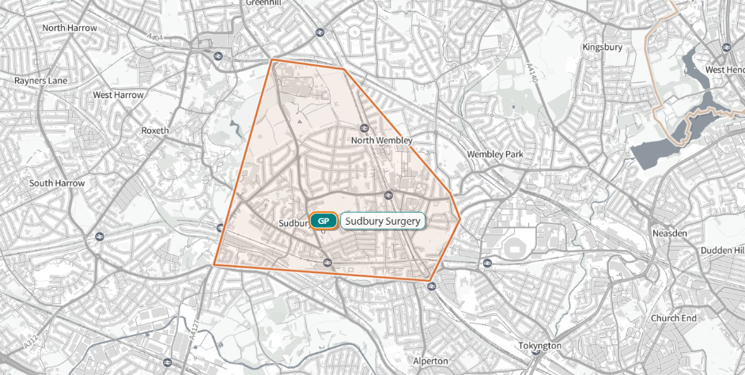

Part 5 – GP Patient Registration Standard Operating Principles for Primary Medical Care (General Practice)

https://www.england.nhs.uk/publication/primary-medical-care-policy-and-guidance-manual-requesting-documentary-information-from-patients-annexes/

Annex 1 – Memorandum of Information for Sudbury Surgery

The purpose of this Memorandum of Information (MOI) is to provide potential bidders with supplementary information relating to the services provided at this practice and the wider ICB strategy into which this fits.

Background

Sudbury Surgery E84685 is an Alternative Provider Medical Services (APMS) practice with a registered raw list size of 7,788 as of 1 April 2026. The APMS framework allows contracts with organisations (such as private companies or third sector providers) other than general practitioners / partnerships of GPs to provide primary care services. The practice was inspected by the Care Quality Commission in 2018 and rated Good overall. The CQC rating has kept unchanged following a review of the practice data in July 2023. The practice has an open list.

NHS England commissioned the APMS contract for Sudbury Surgery in 2016 for period of five years with the contract period 1st November 2016 to 31 October 2021 with option to extend for a further five years. The contract was extended for second contractual term by Brent Primary Care Commissioning Committee in December 2020 for a period of 5 years.

National Context

The Delivery Plan for Access Recovery in primary care was published on 9 May 2023. The plan sets out two central aims:

to tackle the 8am rush and reduce the number of people struggling to contact their practice, and

for patients to know on the day they contact their practice how their request will be managed.

Over the two-year implementation period (2023–25), the plan supported general practices in transitioning to Modern General Practice, defined as:

“A modern approach to general practice that makes it easier for patients to contact their practices by phone or online and supports practices to rapidly assess the nature and urgency of requests by involving the whole practice team.”

As of 2025, this model is now embedded across most practices, with NHS England reporting:

Over 90% of practices enabling patients to use the NHS App for messaging, booking, and prescriptions.

Widespread adoption of cloud-based telephony, faster care navigation, and self-referral pathways.

Expanded Pharmacy First services, allowing patients to access treatment for common conditions without needing a GP appointment.

The focus for 2025/26 is now on realising the benefits of these changes - improving patient experience, reducing pressure on GPs, and enhancing digital access and care navigation.

Brent Demographics

Brent population is to be around 344,500 as at June 2023 according to the office of national statistic. This makes Brent the 5th largest borough in London in terms of population size and the 30th largest in England (out of 296 areas).

Brent is densely populated – with a density of 7,969 people per square kilometre – the 14th highest in England, and the highest in Outer London.

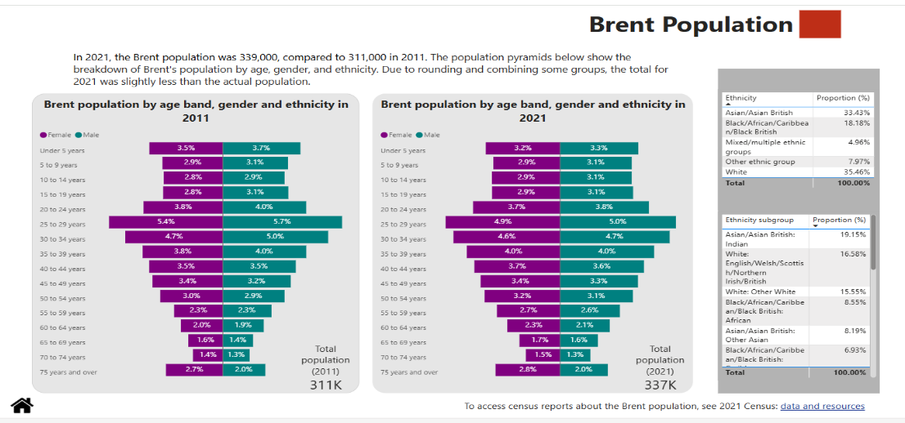
Figure 1 Brent population

The population of Brent grew by 6.2% over the period 2013-2023, similar to the rise across London and England (6.0% and 7.0%). Growth in Brent was relatively slow compared with the previous decade, reflecting pandemic impacts on the population and falling birth rates.
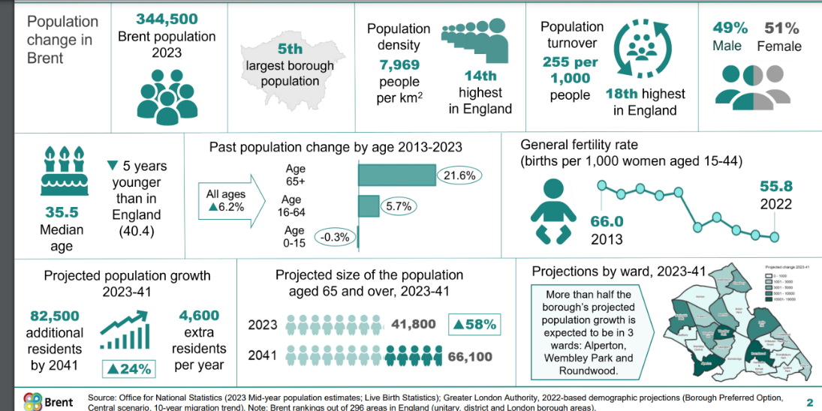
Figure 2 – Brent population change

Over the long term (2023-41), the number of residents aged 65 and over is projected to increase by 58% – an additional 24,300 older residents. More than half this increase is within the age 75+ age group (+13,000, up 71%). Over the same period, the child population aged under 16 is expected to see less change, increasing by 12% between 2023 and 2041 (+ 7,900 children).

With regars to life expectancy in Brent , a 65 year old woman is exptected to live an average of an additional 22 years. This is similar to London and England average. While a 65 year old man is expecgted to live an average of 18 years.

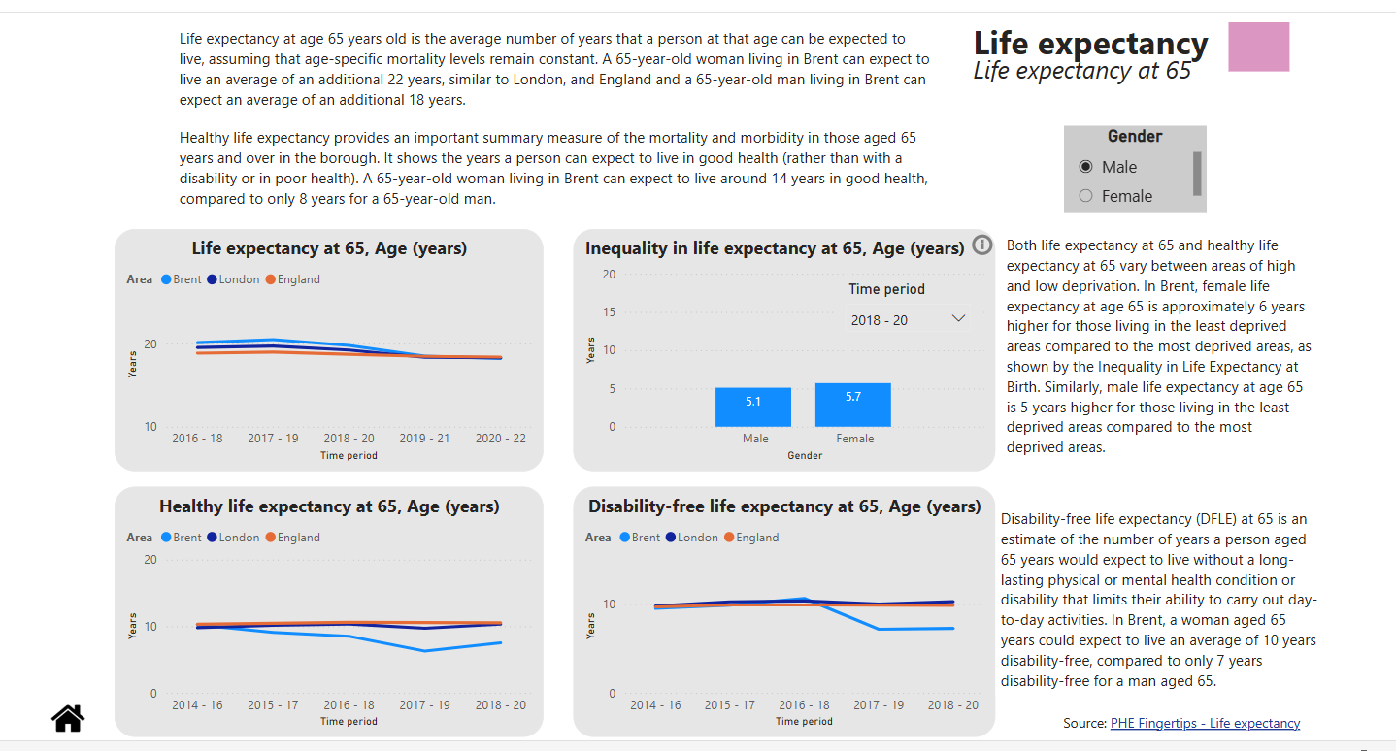
Figure 3 – Life expectancy

According to census data 2021, Brent is one of the most ethnically diverse boroughs in London. The latest GLA projections indicate that almost two thirds of the population (64%) are from Black, Asian and Minority ethnic (BAME) groups, the third highest in London, after Newham and Redbridge.

Brent has a large Asian population: one third of residents are from Asian groups compared with 20% across London.

Around 17% of Brent residents were from Black ethnic groups, higher than the London average (13%). Around 16% of residents are White British, the second lowest rate in London, after Newham (13%). Brent also has a significant population from White minority groups: 16% are from the ‘White Other’ group and 3% are White Irish.

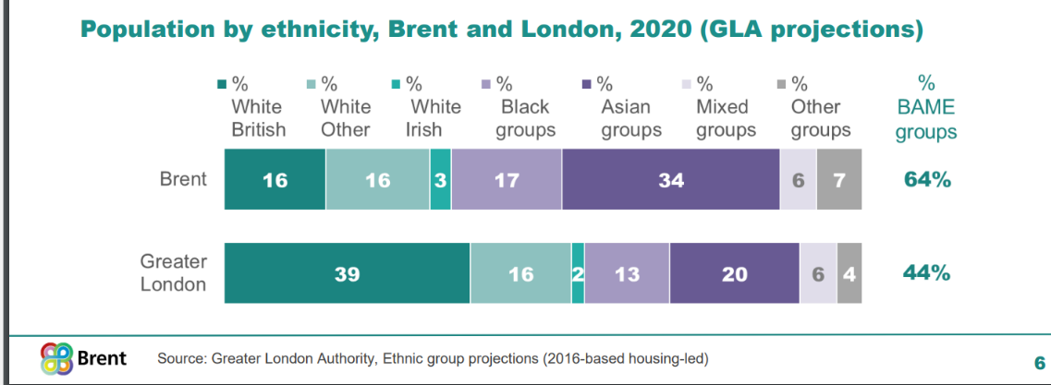
Figure 4 – Population by ethnicity

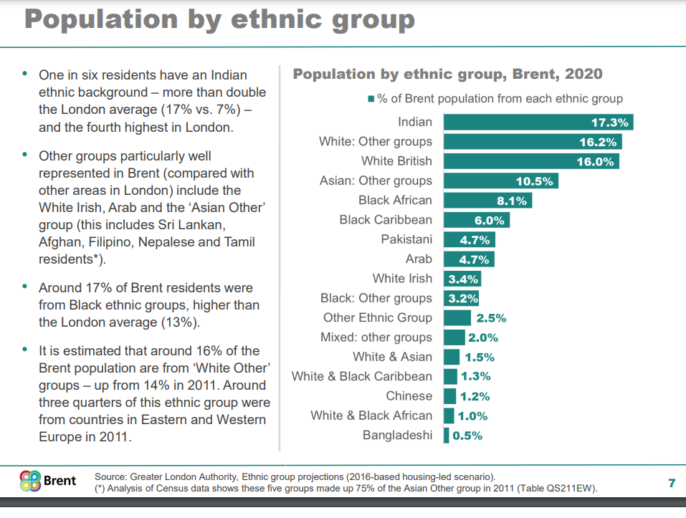
Figure 5 – Population by ethnic group

The most highly deprived areas in the borough are concentrated in Stonebridge and Harlesden. Brent has one LSOA that is within the 5% most deprived in England, and this is located in north Stonebridge. The least deprived areas in the borough are located in the north west, in the wards of Kenton and Northwick Park.

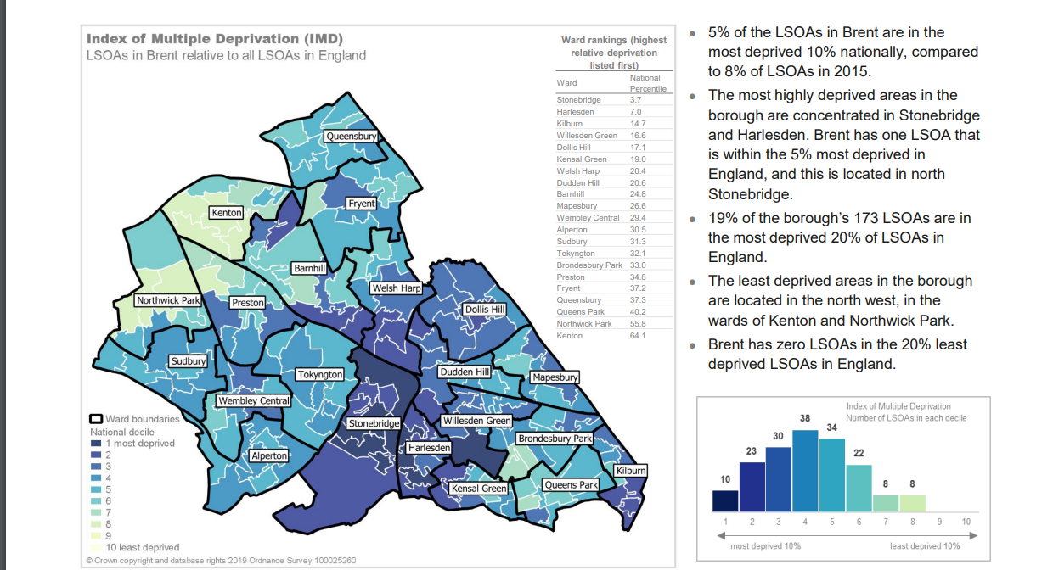
Figure 6 – Indices of deprivation

According to 2021 census, 47.2% of Brent residents described their health as "very good", increasing from 41.4% in 2011. Those describing their health as "good" fell from 35.3% to 33.8%. These are age-standardised proportions. The proportion of Brent residents describing their health as "very bad" decreased from 2.0% to 1.4%, while those describing their health as "bad" fell from 5.6% to 4.2%.

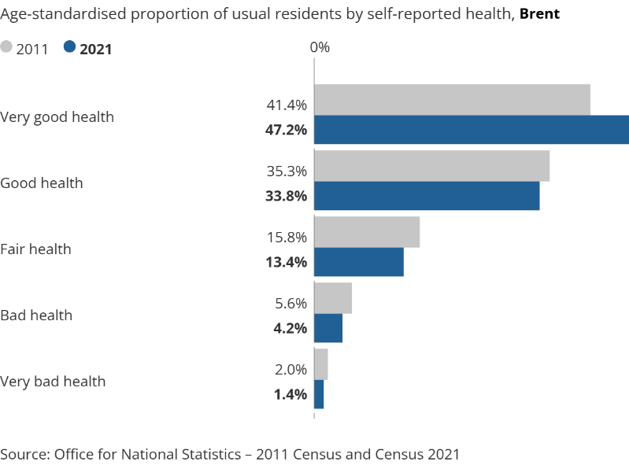
Figure 7 - Brent residents described their health

According to Brent Joint needs assessment the proportion of adults classified as obese in Brent is currently stable at 19%, which is lower than London (21%) and England (26%). However, when looking at the combined overweight and obese adult levels, there is an upward trend in Brent from 2020/21 with a rate of 61% which is higher than the London average of 57% and lower than England's 64%.

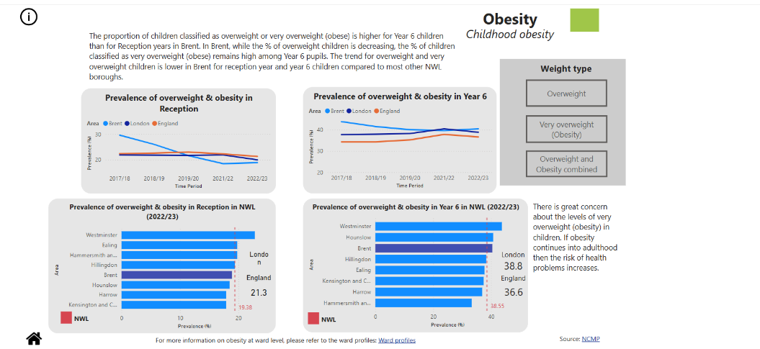
Figure 8 – Childhood obesity

In Brent, the percentage of physically active adults is 60%, which is substantially lower than in London (65%) and England (66%).

Percentage of physically active adults (18+)
Time Period | Brent | London | England
2017/18 | 59.81 | 66.41 | 66.26
2018/19 | 56.30 | 66.58 | 67.21
2019/20 | 59.73 | 65.16 | 66.38
2020/21 | 55.95 | 64.86 | 65.94
2021/22 | 60.10 | 66.82 | 67.31
2022/23 | 59.65 | 66.35 | 67.14

The proportion of children classified as overweight or very overweight (obese) is higher for Year 6 children than for Reception years in Brent. In Brent, while the % of overweight children is decreasing, the % of children classified as very overweight (obese) remains high among Year 6 pupils. The trend for overweight and very overweight children is lower in Brent for reception year and year 6 children compared to most other NWL boroughs.

Prevalence of overweight in reception, Proportion (%)
Time Period | Brent | London | England
2017/18 | 14.7 | 11.7 | 12.8
2018/19 | 12.8 | 11.6 | 12.9
2019/20 | 10.1 | 11.6 | 13.1
2021/22 | 9.4 | 11.1 | 12.1
2022/23 | 10.0 | 10.7 | 12.2

The rate of inpatient stays in secondary mental health services is higher in Brent compared to both London and England.

Estimated prevalence of common mental disorders (16+), Proportion (%), 2017
Time Period | Brent | London | England
2017 | 20.77 | 19.27 | 16.92

Estimated prevalence of common mental disorders (65+), Proportion (%), 2017
Time Period | Brent | London | England
2017 | 12.61 | 11.29 | 10.25

Inpatient stays in secondary mental health services (all ages), rate per 100,000
Time Period | Brent | London | England
2017/2018 | 280.1 | 286.5 | 238.5
2018/2019 | 308.4 | 287.7 | 242.8
2019/2020 | 328.9 | 276.4 | 241.5

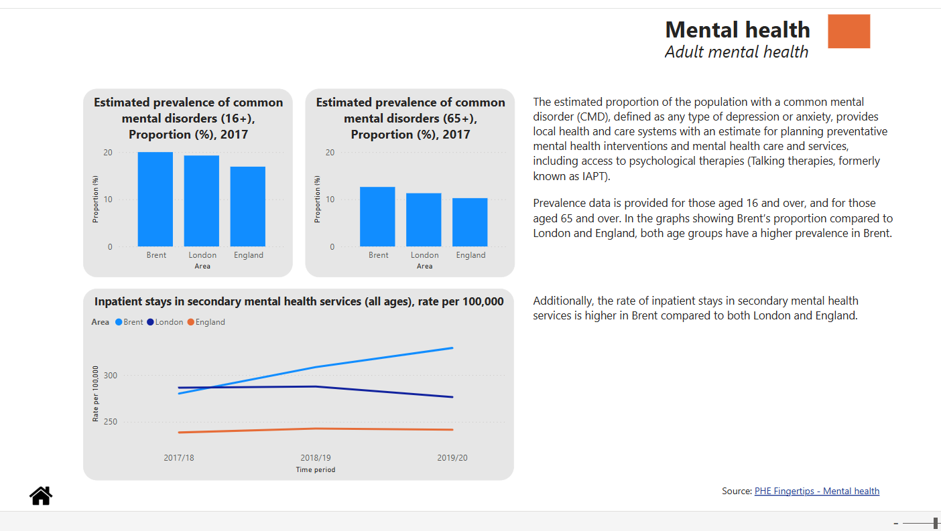
Figure 9 – Adult Mental health

In 2021, one in six children aged 6-16 years were identified as having a probable mental disorder based on a series of questions from a survey which assessed the mental health of Children and young people in the UK according to NHS digital

Hospital admissions for mental health conditions (Under 18 years old), rate per 100,000
Time Period | Brent |  | London |  | England
2022/23 | 75.1 |  | 61.7 |  | 80.8
Source: PHE Fingertips
Percentage of school pupils with social, emotional and mental health needs, Proportion (%)
Time Period |  | Brent |  | London |  | England
2023 |  | 2.5 |  | 2.8 |  | 3.3
Source: PHE Fingertips

New referrals to secondary mental health services (Under 18 years old), rate per 100,000
Time Period | Brent | London | England
2018/19 | 4748.8 | 4574.9 | 5994.2
2019/20 | 3583.7 | 4638.9 | 6977.4
Source: PHE Fingertips

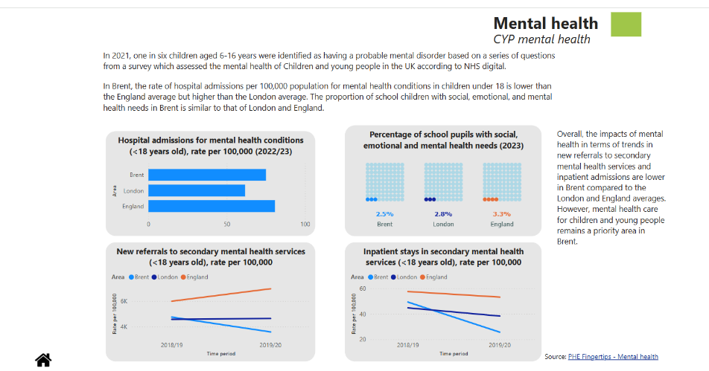

Figure 10 – Brent Children’s Mental Health

In the 2011 Census, the vast majority of people in Brent described their health as good or very good (eighty one percent), only five percent of local people reported poor or very poor health.

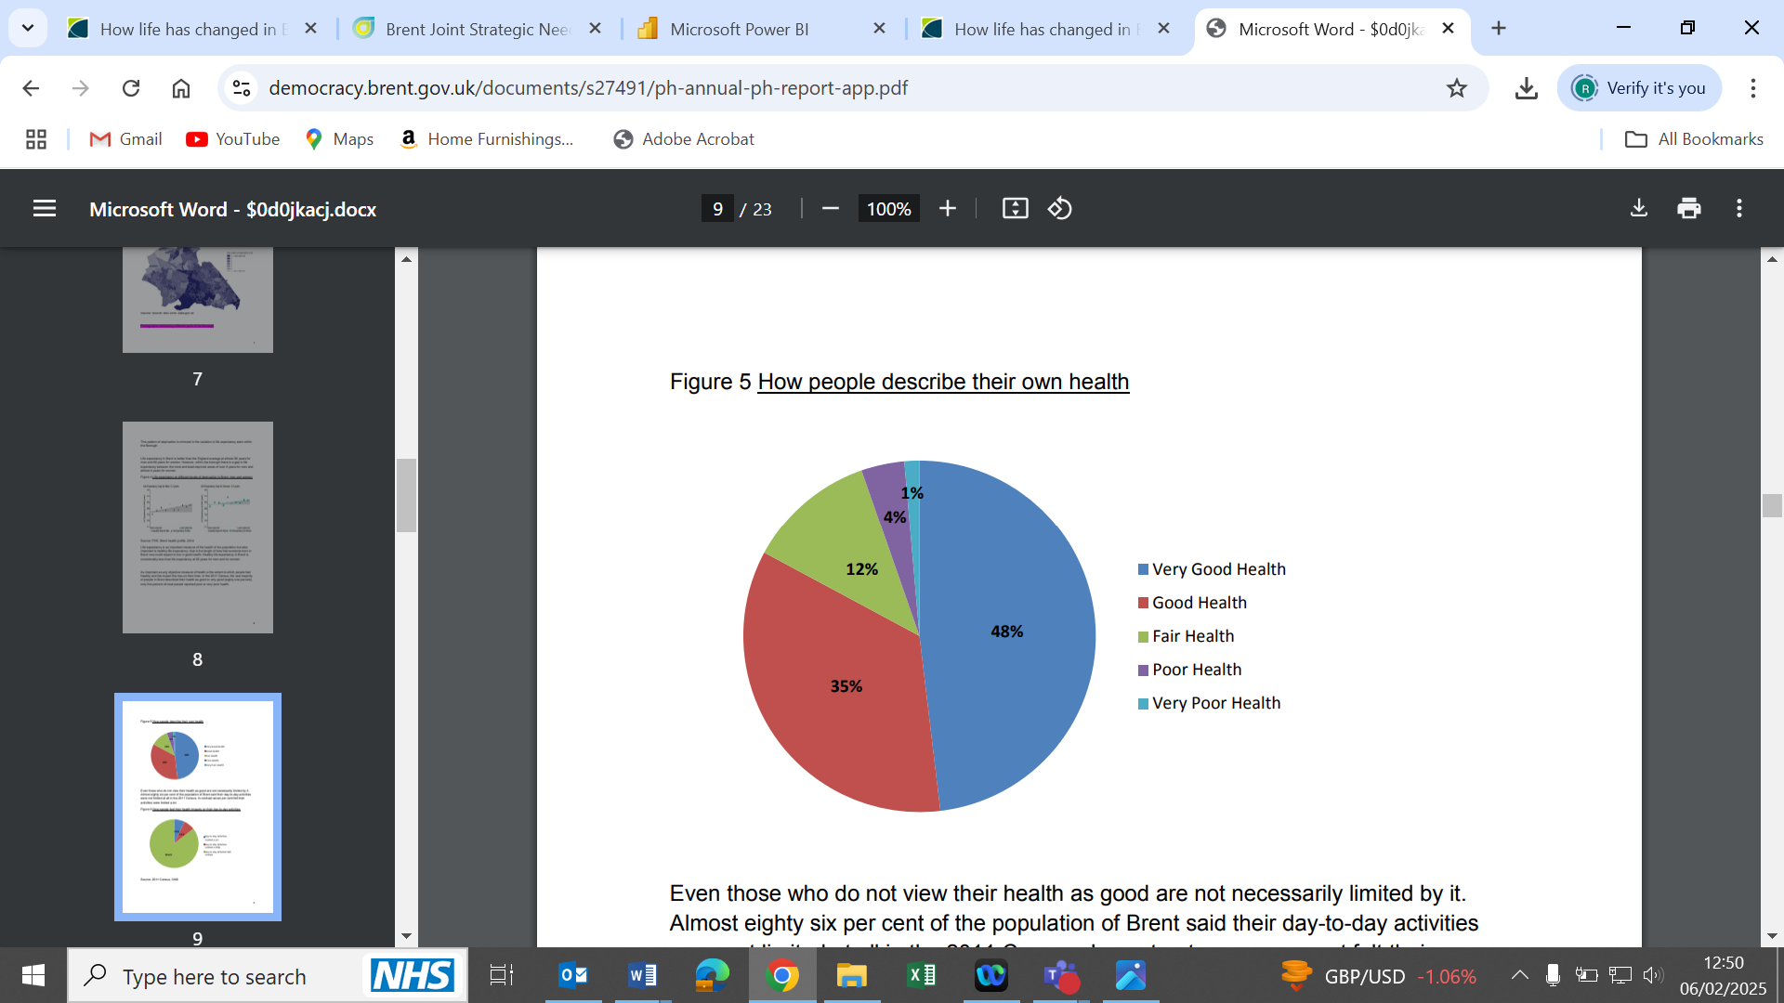

Figure 11 – How Brent population rate their health

9.3% of Brent's residents suffer from diabetes, and it is estimated that 17% of all deaths in Brent can be attributed to diabetes. A study from NHS England revealed that one in three people (33.2%) who have died in hospital in England following a diagnosis of Covid-19 also had diabetes.

Diabetes QOF prevalence (17+ yrs), Proportion
Year | Brent | England | London
2009/10 | 6.62 | 5.4 | 5.25
2010/11 | 6.78 | 5.54 | 5.36
2011/12 | 7.71 | 5.76 | 5.59
2012/13 | 7.84 | 6.01 | 5.82
2013/14 | 7.92 | 6.21 | 6
2014/15 | 8.04 | 6.37 | 6.14
2015/16 | 8.24 | 6.55 | 6.32
2016/17 | 8.55 | 6.67 | 6.46
2017/18 | 8.64 | 6.79 | 6.51
2018/19 | 8.79 | 6.93 | 6.63
2019/20 | 8.98 | 7.08 | 6.76
2020/21 | 8.68 | 7.11 | 6.7
2021/22 | 8.58 | 7.26 | 6.75

Hypertension QOF Prevalence, Proportion %
Time Period | Brent | London | England
2013/14 | 11.99 | 11.05 | 13.73
2014/15 | 11.98 | 11.06 | 13.79
2015/16 | 11.95 | 11.05 | 13.81
2016/17 | 12.21 | 11.08 | 13.83
2017/18 | 12.20 | 11.04 | 13.94
2018/19 | 12.23 | 10.96 | 13.96
2019/20 | 12.01 | 11.02 | 14.10
2020/21 | 11.40 | 10.77 | 13.93
2021/22 | 11.11 | 10.64 | 13.97
Source: PHE Fingertips: Hypertension

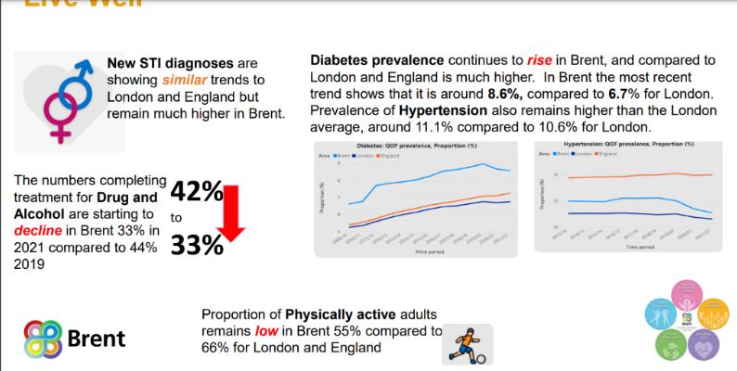
Figure 12 – Drug and alcohol / diaetes and Physical activity

In Brent, the number of children getting vaccinated is lower than in London and England. The graphs below show how many children got their vaccines over time at different ages. Each borough is aiming for a 95% vaccination rate as set nationally for each borough to achieve.

Immunisations by First birthday in Brent, Proportion (%)
Time Period | Rotavirus | Dtap IPV Hib | PCV
2017/18 | 85.8 | 90.5 | 90.1
2018/19 | 85.1 | 89.1 | 88.7
2019/20 | 84.5 | 88.1 | 88.5
2020/21 | 84.9 | 86.5
2021/22 | 84.7 | 87.7 | 90.6
2022/23 | 85.3 | 87.2 | 91.6
Source: PHE Fingertips

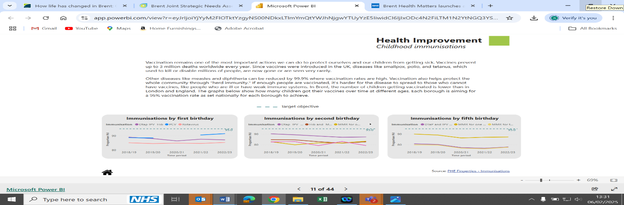
Figure 13 – Child Immunisations

The numbers of children with SEN support and EHC plans give an indication of the level of demand for SEN services in Brent and can be used as a proxy measure for identified special educational needs in the borough. The bar chart to the left shows the absolute numbers for Brent, London, and England, with a filter that allows selection by area

SEN Support Prevalence %
Time Period | Brent | London | England
2015/16 | 9.9 | 11.7 | 11.6
2016/17 | 9.5 | 11.4 | 11.6
2017/18 | 9.8 | 11.3 | 11.7
2018/19 | 9.9 | 11.4 | 11.9
2019/20 | 9.9 | 11.5 | 12.1
2020/21 | 10.7 | 11.4 | 12.2
2021/22 | 10.3 | 11.7 | 12.6
2022/23 | 10.9 | 12.1 | 13
2023/24 | 11.1 | 12.7 | 13.6

Special educational needs and disabilities (SEND) can affect a child's ability to learn. Most children with special educational needs are provided SEN Support by their schools or similar educational settings.

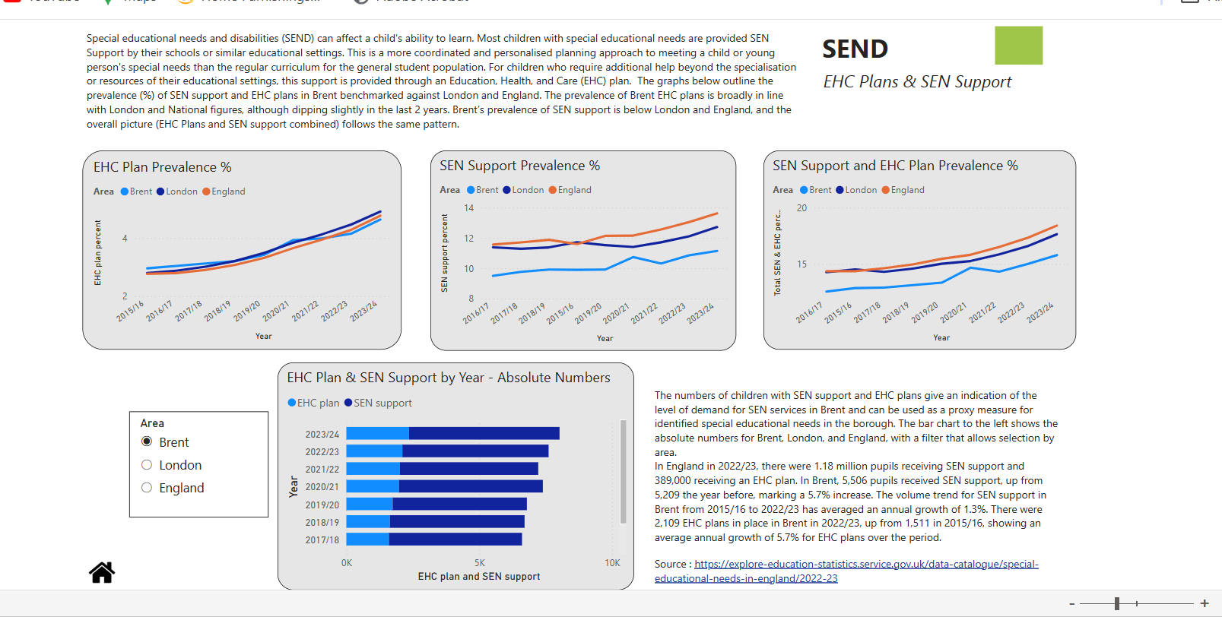
Figure 14 - SEND

Practice Demographics

The practice is located in London borough of Brent. The practice ethnicity estimates shows a population base of 3.6% Mixed, 50.7% Asian, 11.7% Black, 8.3% Other non-white ethnicities.

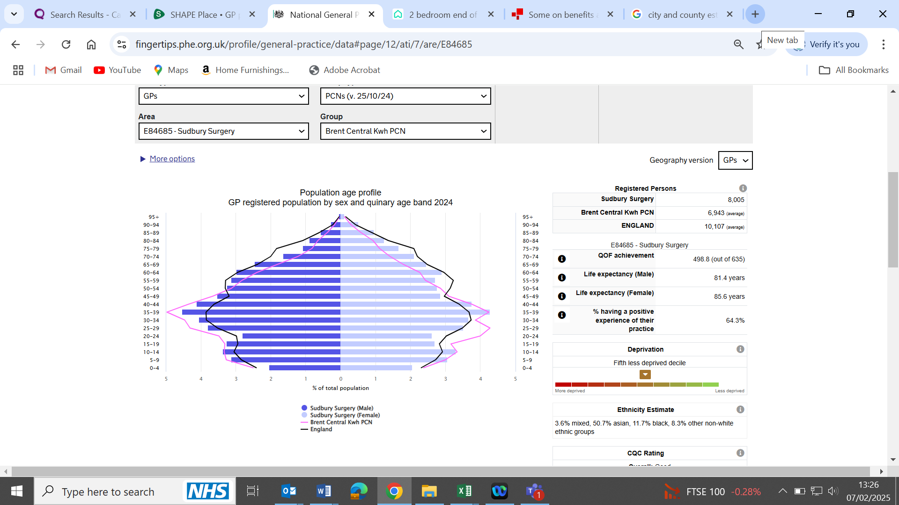
Figure 15 – Practice population profile

The map below shows the geographical distribution of 7,788 patients registered with the practice.

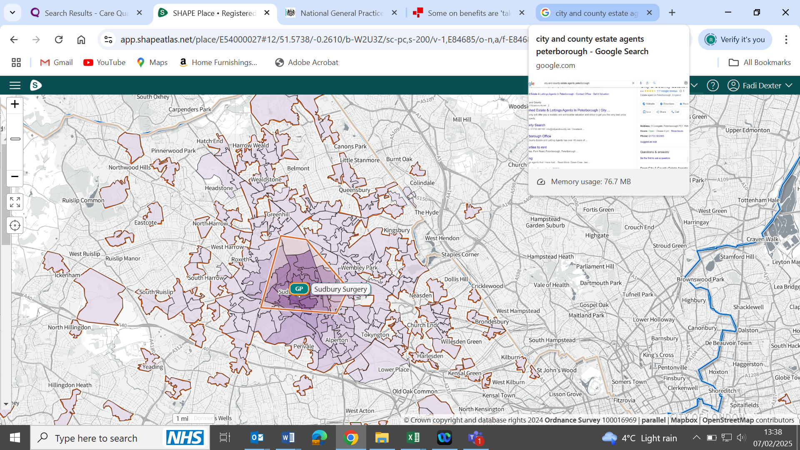
Figure 16 – Practice patient distribution in relation to the practice’s catchment area

The actual number of registered patients by age at the practice is per the following

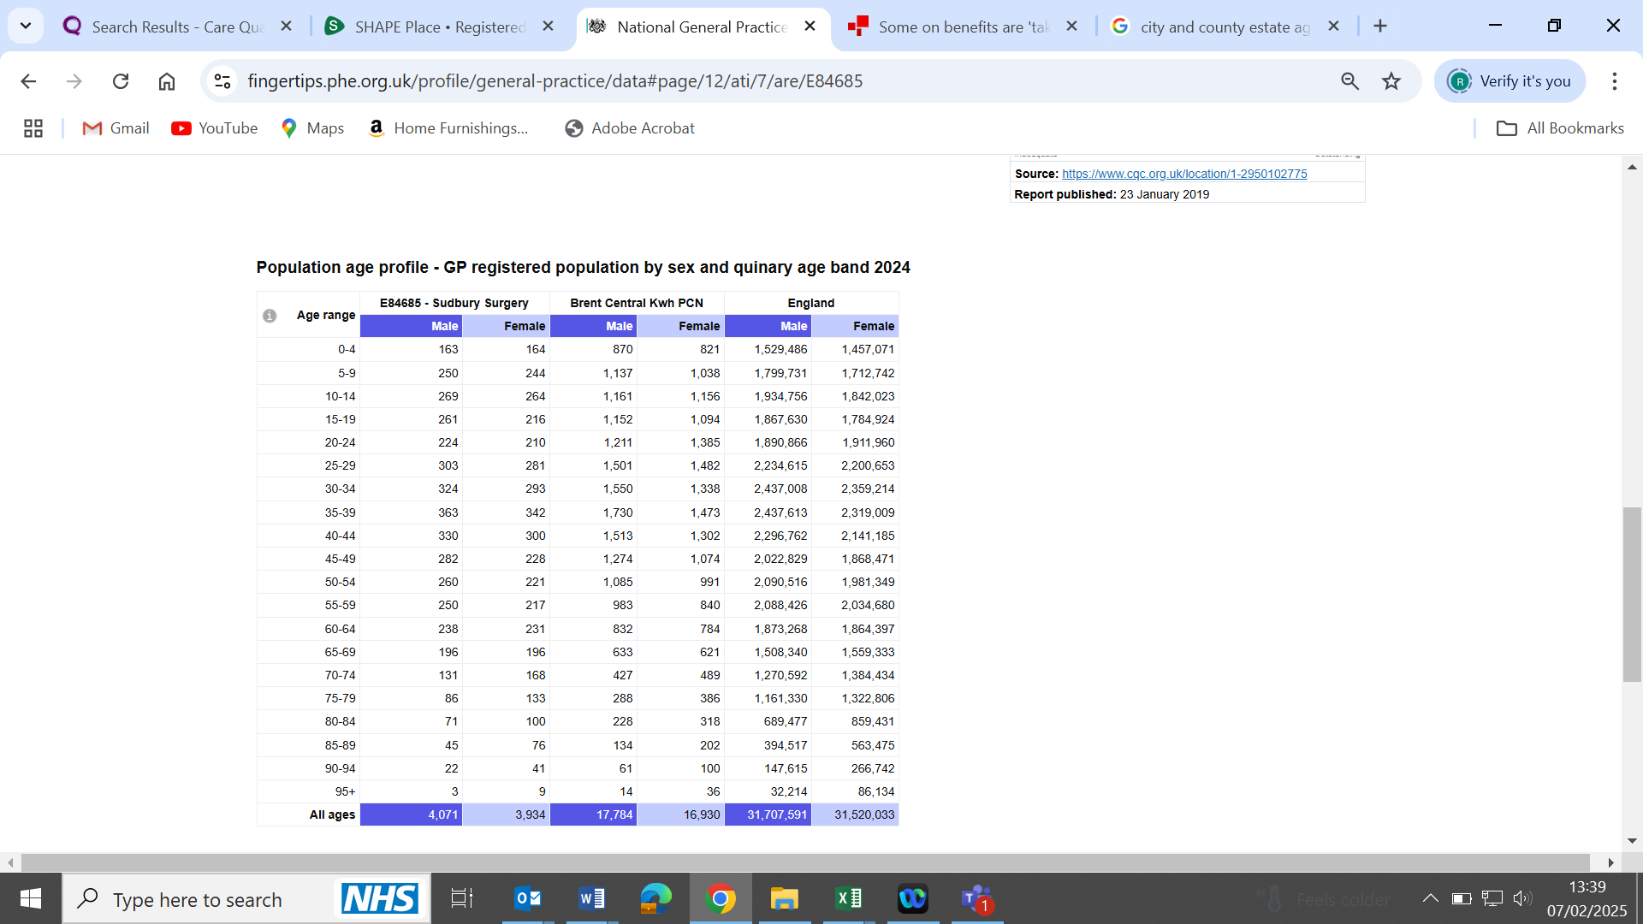
Figure 17 – Practice population age

Local GP Context and Capacity

There are 7 other practices within a 1 mile radius of the practices. These practices have open lists and can accept patients.

Practice Name | Distance  (in Miles) | Overall CQC rating
Sunflower Medical Centre | 0.7 | Good
Premier Medical Centre | 0.7 | Good
SMS Medical Centre | 0.7 | Good
Pearl Medical Centre | 0.7 | Good
Wembley Practice | 0.7 | Good **
Lancelot Medical Centre | 0.8 | Good
Elm Trees Sugery | 1 | Good
** APMS contract to be reprocured

The map below shows the distribution of registered patients in relation to other practices within 1 mile radius.
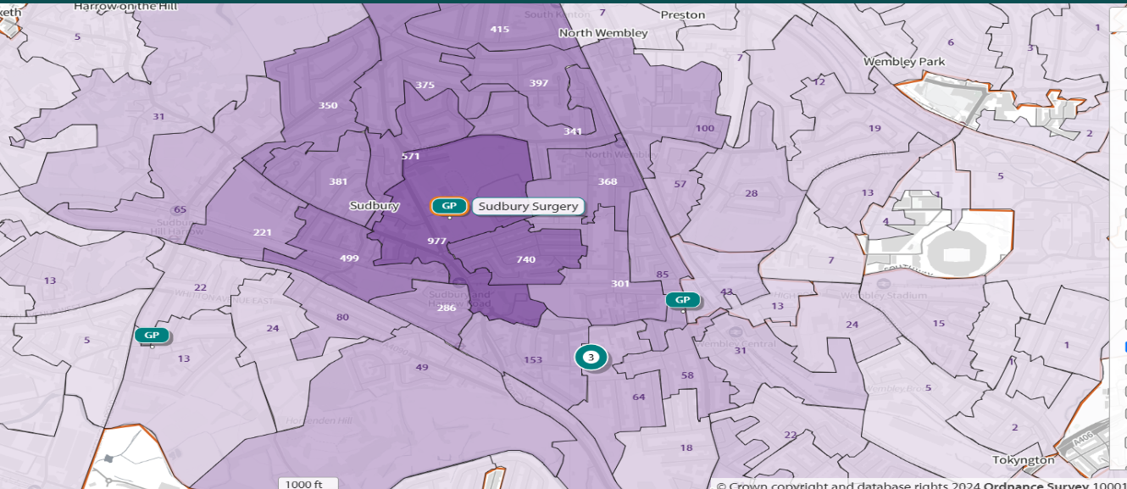
Figure 18- Practice patient distribution in relation to practices wthin a 1 mile radius

Primary Care Network

The practice is a member of the Central K&W Primary Care Network.

There are no significant barriers when considering patient access. Walking distances to local GP practices would be determined by the home address of patients.

These practices are within the same PCN which can be accessed by local residents.

These practices have an open list.

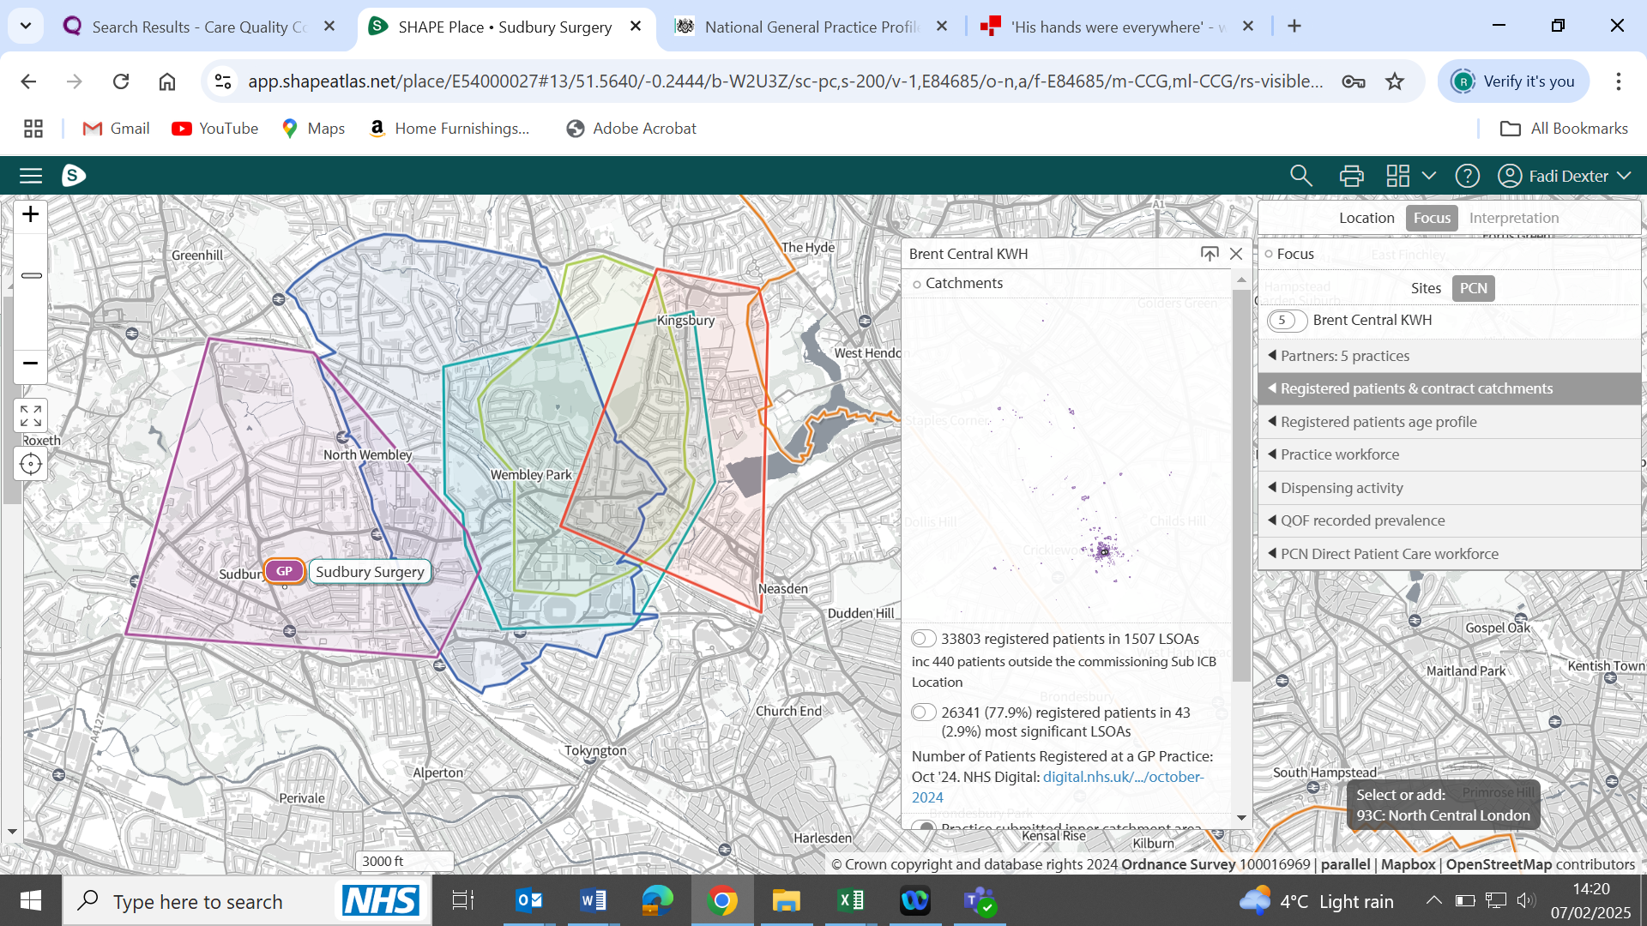
Figure 19 - Practice catchment area and PCN practices catchment area

Premises

Sudbury Surgery is located at Sudbury Primary Care Centre, Vale Farm, Watford Road Wembley HA0 3HG.

The practice has a lease in place with NHS Community Health Partnerships (CHP) until 05/11/2032.

The practice reimbursable charges under NHS Premises Cost Direction is per the following: the annual rent is £337,824.23 and rate charges are £12,906.21

Contract Price

In terms of the contract price there will be an annual uplift in line with nationally agreed rates.

Overview | Healthcare-associated infections: prevention and control in primary and community care | Guidance | NICE
NHS England » National infection prevention and control
https://www.england.nhs.uk/wp-content/uploads/2023/05/PRN00283-delivery-plan-for-recovering-access-to-primary-care-may-2023.pdf
NHS England » Modern general practice model
Road to recovery: the government's 2025 mandate to NHS England - GOV.UK
Good-Practice-Screening-Guide-2020.pdf
Healthcare Professional Alert Notices - NHS Resolution
https://www.england.nhs.uk/ournhspeople/
Brent needs assessment, https://data.brent.gov.uk/dataset/emgrl/brent-joint-strategic-needs-assessment-jsna-2023
Population change in Brent https://data.brent.gov.uk/download/2yq7q/vws/Population%20change%20briefing%20101024.pdf
Brent joints needs assessment, https://app.powerbi.com/view?r=eyJrIjoiYjYyM2FlOTktYzgyNS00NDkxLTlmYmQtYWJhNjgwYTUyYzE5IiwidCI6IjIxODc4N2FiLTM1N2YtNGQ3YS1hZjljLTU4NzBlM2QyZWI4MCIsImMiOjh9
Community profiling: diversity in Brent, https://data.brent.gov.uk/download/vqkrd/733/Community%20profile%20evidence%20pack%20-%202021%20Census%2011.05.21%20AV.pdf
Community Profiling Diversity in Brent – Evidence Pack – as above
Brent 2019 Indices of Deprivation, https://data.brent.gov.uk/download/2rkw4/tc4/JSNA%20Indices%20of%20Deprivation%20Final%20v2.pdf
Brent Health Matters Annual Report 2023/2024, https://democracy.brent.gov.uk/documents/s143692/8a.+Appendix+1+-+Brent+Health+Matters+Annual+Report.pdf
Brent Joints needs assessment https://app.powerbi.com/view?r=eyJrIjoiYjYyM2FlOTktYzgyNS00NDkxLTlmYmQtYWJhNjgwYTUyYzE5IiwidCI6IjIxODc4N2FiLTM1N2YtNGQ3YS1hZjljLTU4NzBlM2QyZWI4MCIsImMiOjh9
Brent Joints needs assessment, https://app.powerbi.com/view?r=eyJrIjoiYjYyM2FlOTktYzgyNS00NDkxLTlmYmQtYWJhNjgwYTUyYzE5IiwidCI6IjIxODc4N2FiLTM1N2YtNGQ3YS1hZjljLTU4NzBlM2QyZWI4MCIsImMiOjh9
Brent Joints needs assessment https://app.powerbi.com/view?r=eyJrIjoiYjYyM2FlOTktYzgyNS00NDkxLTlmYmQtYWJhNjgwYTUyYzE5IiwidCI6IjIxODc4N2FiLTM1N2YtNGQ3YS1hZjljLTU4NzBlM2QyZWI4MCIsImMiOjh9
Brent Joints needs assessment https://app.powerbi.com/view?r=eyJrIjoiYjYyM2FlOTktYzgyNS00NDkxLTlmYmQtYWJhNjgwYTUyYzE5IiwidCI6IjIxODc4N2FiLTM1N2YtNGQ3YS1hZjljLTU4NzBlM2QyZWI4MCIsImMiOjh9
Brent Joints needs assessment https://app.powerbi.com/view?r=eyJrIjoiYjYyM2FlOTktYzgyNS00NDkxLTlmYmQtYWJhNjgwYTUyYzE5IiwidCI6IjIxODc4N2FiLTM1N2YtNGQ3YS1hZjljLTU4NzBlM2QyZWI4MCIsImMiOjh9
Brent Joints needs assessment https://app.powerbi.com/view?r=eyJrIjoiYjYyM2FlOTktYzgyNS00NDkxLTlmYmQtYWJhNjgwYTUyYzE5IiwidCI6IjIxODc4N2FiLTM1N2YtNGQ3YS1hZjljLTU4NzBlM2QyZWI4MCIsImMiOjh9
Annual report of the Director of Public Health for Brent, https://democracy.brent.gov.uk/documents/s27491/ph-annual-ph-report-app.pdf
Brent Joints needs assessment https://app.powerbi.com/view?r=eyJrIjoiYjYyM2FlOTktYzgyNS00NDkxLTlmYmQtYWJhNjgwYTUyYzE5IiwidCI6IjIxODc4N2FiLTM1N2YtNGQ3YS1hZjljLTU4NzBlM2QyZWI4MCIsImMiOjh9
Brent Joints needs assessment https://app.powerbi.com/view?r=eyJrIjoiYjYyM2FlOTktYzgyNS00NDkxLTlmYmQtYWJhNjgwYTUyYzE5IiwidCI6IjIxODc4N2FiLTM1N2YtNGQ3YS1hZjljLTU4NzBlM2QyZWI4MCIsImMiOjh9
Brent Joints needs assessment, https://app.powerbi.com/view?r=eyJrIjoiYjYyM2FlOTktYzgyNS00NDkxLTlmYmQtYWJhNjgwYTUyYzE5IiwidCI6IjIxODc4N2FiLTM1N2YtNGQ3YS1hZjljLTU4NzBlM2QyZWI4MCIsImMiOjh9
Brent Joints needs assessment, https://app.powerbi.com/view?r=eyJrIjoiYjYyM2FlOTktYzgyNS00NDkxLTlmYmQtYWJhNjgwYTUyYzE5IiwidCI6IjIxODc4N2FiLTM1N2YtNGQ3YS1hZjljLTU4NzBlM2QyZWI4MCIsImMiOjh9
Brent Joints needs assessment, https://app.powerbi.com/view?r=eyJrIjoiYjYyM2FlOTktYzgyNS00NDkxLTlmYmQtYWJhNjgwYTUyYzE5IiwidCI6IjIxODc4N2FiLTM1N2YtNGQ3YS1hZjljLTU4NzBlM2QyZWI4MCIsImMiOjh9
National general practice profile, https://fingertips.phe.org.uk/profile/general-practice/data#page/12/ati/7/are/E84685
As above
SHAPE maps, https://app.shapeatlas.net/place/E54000027
Department of health national general practice profile, https://fingertips.phe.org.uk/profile/general-practice
SHAPE maps, https://app.shapeatlas.net/place/E54000027
SHAPE maps, https://app.shapeatlas.net/place/E54000027

